**University of Education**

**Township Campus, Lahore, Pakistan**



**Laboratory Exercises**

*For*

**Computer Communications & Networks Lab**

|  |  |
| --- | --- |
| Lab Instructor |  |
| Course Instructor |  |
| Course code |  |
| Semester |  |

**Department of Information Sciences, Division of Science & Technology**

**Computer Communication & Networks Lab**

|  |
| --- |
| **Objectives**  At the end of the course students should  ● learn the basic elements of data communication system  ● describe communication protocols and data transmission modes  ● explain the use of computer network  ● describe different components of computer network  identify different types of network  ● understand what is internet and e-mail and its uses in modern  communication  ● appreciate the use of satellite communication |

# Table of Contents

|  |  |  |
| --- | --- | --- |
| **Lab No.** | **Lab Title** | **Page** |
| Lab # 1 | CISCO Packet Tracer Introduction | 4 |
| Lab # 2 | CISCO Packet Tracer Installation | 8 |
| Lab # 3 | Network Cable Construction | 12 |
| Lab # 4 | Mapping Real Time Data | 16 |
| Lab # 5 | Configuring Router from Command Line Interface | 22 |
| Lab # 6 | Accessing the Router Remotely & WAN | 28 |
| Lab # 7 | Building a WAN between Two LANs | 35 |
| Lab # 8 | Static Routing | 38 |
| Lab # 9 | Networks, IP Addressing Scheme, Subnetting VLSM & Packet Tracer | 45 |
| Lab # 10 | IP Addressing Scheme & VLSM | 51 |
| Lab # 11 | Subnetting Questions with detailed Answers | 55 |
| Lab # 12 | Routing Information Protocol (IP) | 64 |
| Lab # 13 | Enhanced Interior Gateway Routing Protocol (EIGRP) | 74 |
| Lab # 14 | Open shortest Path First (OSPF) | 88 |
| Lab # 15 | Visual Local Area Network (VLAN) | 98 |
| Lab # 16 | VLAN Truck Protocol (VTP) & Spanning Tree Protocol | 105 |

**CCN Lab 1**

**Computer Communications & Networks**

1. **Learning Objectives:**
   * To become familiar with network devices.
   * To become familiar with Physical Network Layout.
   * CISCO packet tracer introduction and installation
2. **Equipment Required:**
   * Workstations
   * Routers
   * Switches
   * NICs
   * Wireless Access Points
   * Ethernet Cables
3. **Introduction:**

Network components and devices are the physical components of a Network. Basic Network devices include:

* Computer ( PC / Server)
* Hubs
* Switches
* Routers
* Network Interface Cards
* Wireless Access Points
* Printers

A brief introduction about these devices is given below:

**Computer**

The personal computer or a PC is typically the desktop computer or the individual notebook. Whereas a server machine is a computer used for some special purpose in an organization or setup like monitoring the network activity in a workplace.

**Hub**

Hub is a network connection device and its basic function is to forward the data on one port to all the other ports regardless of the intended client end. Hubs can be connected to other Hubs to build large networks.

**What Hubs Do**

Hubs and switches serve as a central connection for all of your network equipment and handle a data type known as frames. **Frames carry your data**. When a frame is received, it is amplified and then transmitted on to the port of the destination PC.

In a hub, a frame is passed along or "broadcast" to every one of its ports. It doesn't matter that the frame is only destined for one port. The hub has no way of distinguishing which port a frame should be sent to. Passing it along to every port ensures that it will reach its intended destination. This places a lot of traffic on the network and can lead to poor network response times.

**Switches**

Switch performs the same function as a Hub does but has more advanced features of sending the packets only to intended clients.

A network switch also connects computers to each other, like a hub. Where the switch differs from a hub is in the way it handles **packets of data**. When a switch receives a packet of data, it determines what computer or device the packet is intended for and sends it to that computer only. It does not broadcast the packet to all computers as a hub does which means bandwidth is not shared and makes the network much more efficient. For this reason alone, switches are usually preferred over a hub.

**Routers**

Routers are the network devices meant to route the data from sender to receivers based on destination addresses using the Internet Protocol or simply IP addresses.

A network router is quite different from a switch or hub since its primary function is to route data packets to other networks, instead of just the local computers. A router is quite common to find in homes and businesses since it allows your network to communicate with other networks including the Internet. Essentially, a router bridges the gap between other networks and gives your network access to more features, e.g. a firewall, QoS, traffic monitoring, VPN, and more.

**Access point**

Alternatively referred to as a base station and wireless router, an access point is a wireless receiver which enables a user to connect wirelessly to a network or the Internet. This term can refer to both Wi-Fi and Bluetooth devices. The image shows a Linksys wireless access point router; it utilizes multiple antennas to improve the signal.

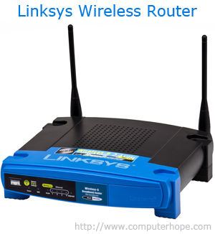

**Network Interface Cards (NIC)**

NICs are the physical adapters attached with the computer to provide network connectivity between the computer and the network.

A network interface card provides the computer with a dedicated, full-time connection to a network. Personal computers and workstations on a local area network (LAN) typically contain a network interface card specifically designed for the LAN transmission technology.

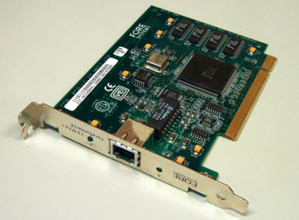

**Printers and Modems**

Network Printers are the network devices used for printing purposes in an environment where more than one computers need to print using the same network.

**Modem**

A modem is a device or program that enables a computer to transmit data over, for example, telephone or cable lines. Computer information is stored digitally, whereas information transmitted over telephone lines is transmitted in the form of analog waves.

Traditional modems used on dialup networks convert data between the analog form used on telephone lines and the digital form used on computers. Standard dial-up network modems transmit data at a maximum rate of 56,000 bits per second (56 Kbps). However, inherent limitations of the public telephone network limit modem data rates to 33.6 Kbps or lower in practice.

Broadband modems that are part of high-speed Internet services use more advanced signaling techniques to achieve dramatically higher network speeds than traditional modems. Broadband modems are sometimes called "digital modems" and those used for traditional dial-up networking, "analog modems." Cellular modems are a type of digital modem that establishes Internet connectivity between a mobile device and a cell phone network.

**CCN Lab 2**

**Computer Communications & Networks**

**Learning Objectives:**

CISCO packet tracer installation

**TASK 1: Physical Network Connectivity**

**Demonstration of a Physical Network**

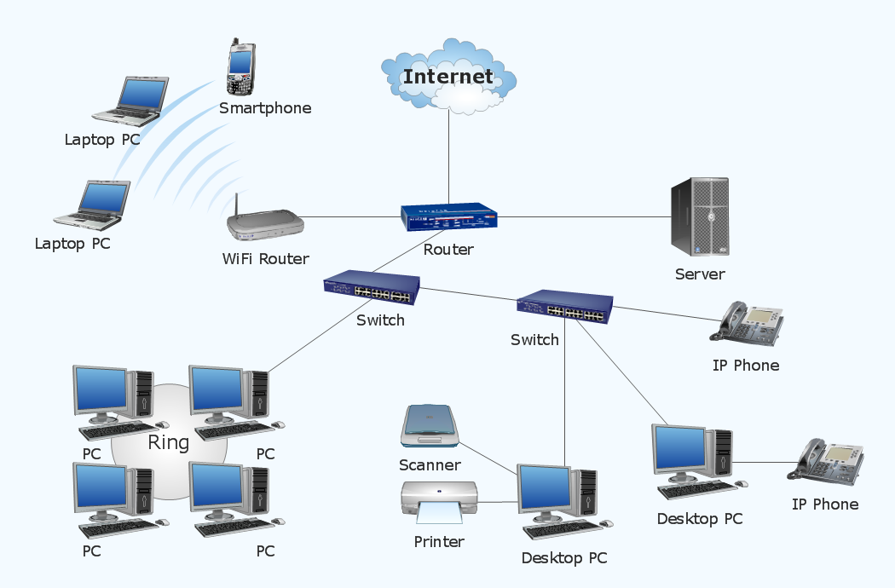

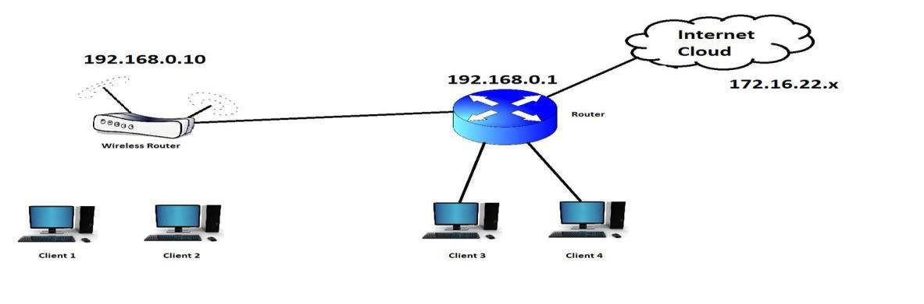

Above is shown an example of the network layout of a physical system. Internet packets travel through a variety of phases before they reach their destined address.

Such an assembly is being shown in the figure above in which remote end PCs are capable of connecting to the Internet through a variety of phases. We will explore them one by one.

**How internet packet travels from source to destination**

1. Internet is being supplied by the ISP (Internet Service Provider) or called

‘Cloud’ to it users and subscribers.

1. Usually physical wired connections are used using Ethernet Cables for connections.
2. In the topology shown above, the internet from the cloud comes and connects to a

Home gateway/ router through a CAT5 Ethernet Cable.

1. Router is a device that routes the internet packets efficiently to its destination address.
2. Computers can be connected directly to internet through the Ethernet cables

|  |  |  |  |  |  |  |  |
| --- | --- | --- | --- | --- | --- | --- | --- |
| connected | to | the | LAN | ports | of | the | Router. |

**Checking Network Connectivity**

Once the computers are connected to the network, you can check the connectivity of the system using the ‘ping’ command in the command prompt window of the computer. For that follow the following steps:

1. Go to Start.
2. Type Run.
3. Type cmd.
4. Type ipconfig.

You will get an output displayed below:

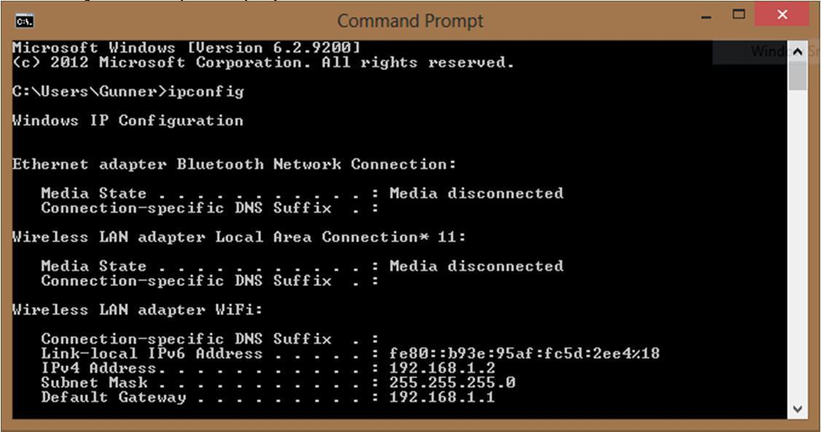

The IP address shown in the above dialog box is the computer’s IP, whereas the Default Gateway is the main existing router that provides your internet connection.

1. Furthermore, the network is extended to a wireless access point placed far away from the main router to provide internet connectivity to the wireless devices.
2. Once the wireless point is configured to ensure the network connectivity, wireless devices can be connect to the same main router.

To get a good technical knowledge and hands on experience on physical networking, we will perform following exercises:

**Exercise # 1**

**Connection and configuration of 2 computers with a router.**

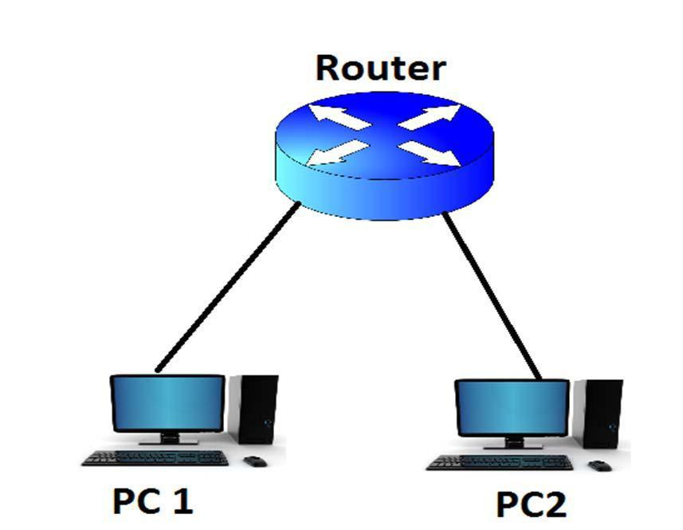

1. Find the Internal IP address of the router by connecting it to your computer using the LAN.
2. Open Command Prompt by typing ‘cmd’ in run window. Then type ‘ipconfig’ to get the IP address.
3. Open the main panel of the router using the IP address above and typing it in the browser window.
4. Find the IP range of the router so that you can assign the IPs to the relative computers.
5. For example, if the IP address of the router is ‘192.168.0.1’ and its IP range is from 192.168.0.1 to 192.168.0.199. This means that you can assign the IP addresses to your end computers within this IP range.
6. Finally, configure your computers with the IP addresses that fall in the above found range by going to Network Connections and changing the TCP IP properties of the Network Connection.
7. Finally, use ‘ping’ commands to test the connectivity.

|  |  |
| --- | --- |
| **Questions:** |  |
| Answer the following questions. |  |
| Q1. Differentiate between router, switch and hub.  Q2. Enlist all commands used in this lab and explain their functionality. |  |

**CCN Lab 3**

**Computer Communications & Networks**

**Network Cable Construction**

**TASK 1: Ethernet Cable Construction**

1. **Learning Objectives:** 
   * To become familiar with the construction of Ethernet Cables.
2. **Equipment Required:**

For each person

* + 2m x CAT5 Network Cable
  + 1 x Wire Crimper and Stripper
  + 6 x RJ45 Heads
  + Cable Tester

1. **Introduction:**

Category 5 cable (CAT5) is a twisted pair cable used for carrying signals. CAT 5 finds its use mostly in structured cabling in computer networks such as Ethernet. It provides up to 100MHz performance and is suitable for different Fast Ethernet (100Mbps) Standards. CAT5 can also be used to carry other signals like telephone and video.

There are two methods set by the Telecommunication Industry Association (TIA), 568A and 568B depending upon the type of connection and interface of the devices. Color Combinations for 568A and 568B are given below:

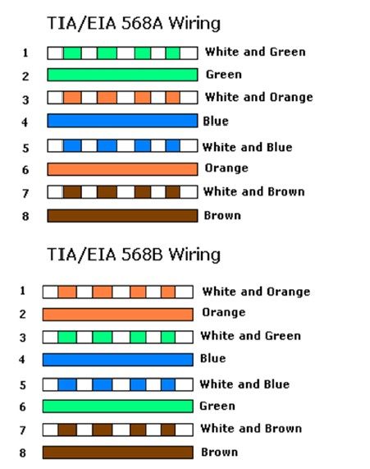

Two different constructions are used according to their connection types:

1. Straight-Through cables
2. Crossover cables.

**4. Procedure:**

**Procedure for Straight-Through Cable Construction:**

Straight-through cable construction is used whenever two different layer devices such as a hub and a PC, are being connected using the **568B color codes.**

Step 1: Determine the distance between devices and devices or plug. Standard lengths are 6ft and 10ft.

Step 2: Cut a piece of CAT 5 cable from the roll according to the desired length.

Step 3: Strip 2 inches of jacket off from one end of the cable using the wire-stripping tool.

Step 4: Hold the 4 pairs of twisted cable tightly where jacket was cut away and reorganize the cable pairs according to 568B standard as shown above. Take care to maintain as much twists as possible since this provides noise cancellation.

Step 5: Flatten, straighten and line-up the wires and trim them slightly from the edge.

Step 6: Place an RJ-45 connector plug on the end of the cable with the prong on the bottom side and color combination arranged from left to right.

Step 7: Gently push the plug onto wires until the copper ends of the wires can be seen through the end of the plug. Make sure the end of the jacket is inside the plug. If everything is correct, crimp the plug hard enough to force the contacts through the insulation on the wires, completing the conducting path.

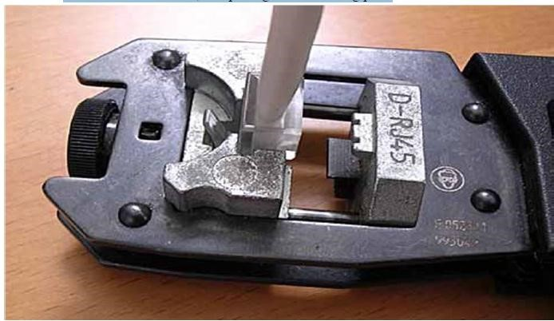

Step 8: Repeat the steps 3-7 using the same scheme at the other end of the cable.

Step 9: Finally after crimping, test the cable using the cable connection testers.

**Procedure for Crossover Cable Construction:**

Crossover cable construction is used whenever two like devices are being connected using the 568A color code at one end and 568B at the other end.

Same steps are followed as in the construction of straight-through cable whereas in this case one of the ends is crimped using 568A color code and the other end by following 568B color combination.

**Exercise:**

Each group of students has to make set of both straight through or cross over LAN cables and get it checked using cable tester.

**CCN Lab 4**

**Computer Communications & Networks**

Mapping real time Data

**1. Learning Objectives:**

Getting knowledge of mapping real time data communication networks in simulation world in CISCO Packet Tracer environment.

**2. Equipment Required:**

A working computer having Cisco packet tracer installed.

**3. Introduction:**

Packet Tracer is a protocol simulator developed at Cisco Systems. Packet Tracer (PT) is a powerful and dynamic tool that displays the various protocols used in networking, in either Real Time or Simulation mode. This includes layer 2 protocols such as Ethernet and PPP, layer 3 protocols such as IP, ICMP, and ARP, and layer 4 protocols such as TCP and UDP. Routing protocols can also be traced. Packet Tracer is a supplement to and not a replacement for experience with real equipment. Students are encouraged to compare the results obtained from Packet Tracer network models with the behavior of real equipment.



**4. Procedure:**

**TASK: Design a simple network using Packet Tracer by configuring router from config tab**

This exercise emphasizes on the need of getting knowledge of simulation environment of the networking area. You are required to create a simple network topology connecting a router to 2 PCs through a switch and ensure the connectivity.

**Step 1** From your Cisco Packet Tracer Window, go to Routers section and select a generic 2621XM Router.



**Step 2** Similarly, place a 2620 switch and 2 PC ( End Devices ) in your Packet Tracers Window.



**Step 3** Now, in order to connect the devices, select the copper straight-through cable from the “Connections” section and connect the devices as shown below:



The above snapshot shows that all the devices have been connected. The network will work fine when all the lights are green. To make the network working, we need to configure the router and the PC’s IP addresses.

**Step 4** Assign IP addresses along with their gateways to the 2 PCs by double clicking the PCs to open their dialog boxes. In this case, we have assigned 192.168.1.2 and 192.168.1.3 respectively.





**Step 5** Configuring the Router:

Open the Router0 property dialog box by double clicking it selecting the “FastEthernet 0/0” from the Config Tab. Assign the IP address 192.168.1.1 to the port. Subnet mask will be added automatically and checkmark the Port Status On.



**Step 6** After done with the configuration, you will see that all the lights are green now showing that network is ready to be operated.



**Step 7** After successfully creating the topology, you can check the connectivity of the network by selecting a packet from the right window and sending it from one PC to another by clicking one by one as shown below:



Finally, you can see that the packet transmission is successful as shown by the message

window:



**CCN Lab 5**

**Computer Communications & Networks**

Configuring Router from Command Line Interface

**Router Mode Switching Commands**

|  |
| --- |
| **Router>**enable *from User Mode to Privilege Mode*  **Router#**configure terminal *from Privilege Mode to Global Conf. Mode*  **Router(config)#**exit *from Global Conf. Mode to Privilige Mode*  **Router#**disable *from Privilege Mode to User Mode* |

**Help and auto completion in CLI of Router**

*You can also type short commands. For example instead of typing* ***enable*** *command you can type* **en**

|  |
| --- |
| **Router>en**  **Router#** |

*If you want to take help you can type first* ***few characters of command*** *and then enter* **?**

|  |
| --- |
| **Router #**e? *it will list the commands starting from e*  **enable exit**  **Router#**? *it will list all commands in privilege mode*  **Router#** en *press Tab Buton on Keyboard and it will* **Router #**enable *auto-complete the command in next line* |

**Basic Router Configurations.**

a. Setting up router hostname.

|  |
| --- |
| **Router>**enable *change to privilege mode*  **Router #**configure terminal *change to global configuration mode*  **Router (config) #** hostname R1 *change router hostname to R1*  **R1(config)#**exit *exit from global conf. mode* |

b. Setting up Console or User Mode Password

|  |
| --- |
| **R1>**enable *change to privilege mode*  **R1#**configure terminal *change to global configuration mode*  **R1(config)#**line console 0 *change to console line sub-mode*  **R1(config-line)#**password dcn123 *set* ***dcn123*** *as password on user mode*  **R1(config-line)#**login *prompt for password*  **R1(config-line)#**exit *exit from line sub-mode*  **R1(config)#**exit *exit from global configuration mode*  **R1#** |

c. Setting up Privilege Mode Password

|  |
| --- |
| **R1>**enable *change to privilege mode*  **R1#**configure terminal *change to global configuration mode*  **R1(config)#**enable password dcn456 *set* ***dcn456*** *as password on privilege mode*  **R1(config)#**exit *exit from global configuration mode*  **R1#** |

d. Removing console/user mode and privilege mode passwords

|  |
| --- |
| **R1#**configure terminal *change to global configuration mode*  **R1(config)#**no enable password *remove password on privilege mode*  **R1(config)#**line console 0 *change to console line sub-mode*  **R1(config-line)#**no password *remove password on user mode*  **R1(config-line)#**no login *remove login prompt*  **R1(config-line)#**exit *exit from line sub-mode*  **R1(config)#**exit *exit from global configuration mode*  **R1#** |

e. Backup of Running Configuration File

|  |
| --- |
| **R1#**copy running-config startup-config *press enter twice*  *This command will backup running-config file in RAM into NVRAM with the file name of startup-config.*  *Following commands can also be used to create backup in NVRAM.*  **R1#write**  **R1#write memory** |

f. Restoring Backup File from NVRAM

|  |
| --- |
| **R1#**copy startup-config running-config *press enter twice*  *This command will copy backup file (startup-config) from NVRAM into RAM* |

g. Disabling DNS Lookup on Router

|  |
| --- |
| *When you enter wrong command,router searches the command in its database.which take time and you can’t work while router is searching for command. To disable this, we usually press* ***ctrl+shift+6*** *to stop translation but following command can also be used.*  **R1#**conf t *change to global configuration mode*  **R1(config)#**no ip domain-lookup *disable dns name lookup*  **R1(config)#**exit *exit from global configuration mode*  **R1#** |

h. Setting a Banner/Welcome Message on the router

|  |
| --- |
| **R1#**conf t *change to global configuration mode*  **R1(config)#**banner motd $*****Authorized Access Only*****$  *Setting Banner to *****Authorized Access Only\*\*\*\*\**  **R1(config)#**exit *exit from global configuration mode*  **R1#** |

i. Assigning IP Address to Router LAN Interface (Fastethernet)

|  |
| --- |
| **R1#**configure terminal *change to global configuration mode*  **R1(config)#**interface fastethernet 0/0 *change to interface fa 0/0 sub-mode*  **R1(config-if)#**ip address 192.168.1.1 255.255.255.0  *Set ip-address for fa 0/0 as 192.168.1.1.*  **R1(config-if)#**no shutdown *activate fa 0/0*  **R1(config-if)#**exit *exit from fa 0/0 sub-mode*  **R1(config)#**exit *exit from global configuration mode*  **R1#** |

j. Verifying IP address and Status of Fastethernet interfaces

|  |
| --- |
| **R1#**show ip interface brief *All interfaces with their status and ip will be shown by this command.*  **R1#**show interfaces fastethernet 0/0 *Displaying particular interface* |

k. Displaying RAM and NVRAM Files

|  |
| --- |
| **R1#**show running-config *it will display all the configuration done on router*  **R1#**show startup-config *it will display all the configuration done on router copied to NVRAM from RAM* |

**Design the following network by configuring router from Command Line Interface**

Use the topology as shown in figure below and follow the Step-1 ro Step-3 as discussed above.

**Note:** For connections, Copper cross-over is used as PCs and router are same functionality devices.



**Step 4**

Assign IP addresses along with their gateways to the 2 PCs by double clicking the PCs to open their dialog boxes. In this case, we have assigned 192.168.1.2 and 192.168.2.2 respectively.

**Note:** The ips’ assigned to both the PCs’ must belong to two different networks in this case.

**Step 5**

Configuring the Router from CLI:

Open CLI (command line interface) of router, you will be prompted a question as shown in the figure below. **Type no and Press enter two times** as we do not want the question answer dialog and want to configure router from commands.



**Step 6**

Assign the IPs to Fastethernet Interfaces Fa 0/0 and Fa 0/1. The IPs should be same as assigned to default gateways of PCs respectively. Also activate the interfaces.

**Step 7**

Verify the interfaces through verification commands.

**Step 8**

After done with the configuration, you will see that all the lights are green now showing that network is ready to be operated.

**Step 9**

**Checking Connectivity**

**Method 1:** After successfully creating the topology, you can check the connectivity of the network by changing the mode from **real mode to simulation mode** and then selecting a packet from the right bar of the PT window and sending it from one PC to another. You will see an animated packet transmitted from source PC to Destination PC. Finally, you will see that the packet transmission is successful as shown by the message window.

**Method 2:** Ping using command prompt window of one PC to another.

**Method 3:** Do the same as Method 1 but in Real Time mode.

**5. Questions:**

Before leaving the lab answer the questions below and show them to your instructor:

Q1. How to verify configuration of console and Privilige mode Passwords?

Q2. Enlist IPv4 classes with their network and host portions. What is the reason behind this classification?

**CCN Lab 6**

**Computer Communications & Networks**

**Accessing the Router Remotely & WAN**

**1. Learning Objectives:**

To learn how to access the router remotely using telnet and SSH Protocols. We will also learn how to connect two routers on WAN via serial cables.

**2. Equipment Required:**

A working computer having Cisco packet tracer installed.

**3. Introduction:**

**WAN:**

A wide area network (WAN) is a telecommunications network or computer network that extends over a large geographical distance. Wide area networks often are established with leased telecommunication circuits.

Business, education and government entities use wide area networks to relay data among staff, students, clients, buyers, and suppliers from various geographical locations. In essence, this mode of telecommunication allows a business to effectively carry out its daily function regardless of location. The Internet may be considered a WAN.

Imagine that you are the primary network engineer for an enterprise TCP/IP internetwork. Your company is building a new building at a site 100 miles away from your corporate headquarters. You will of course install a LAN throughout the new building, but you also need to connect that new remote LAN to the rest of the existing enterprise TCP/IP network.

To connect the new building’s LAN to the rest of the existing corporate network, you need some kind of a WAN. At a minimum, that WAN needs to be able to send data from the remote LAN back to the rest of the existing network and vice versa. Leased line WANs do exactly that, forwarding data between two routers.

From a basic point of view, a leased line WAN works a lot like an Ethernet crossover cable connecting two routers, but with few distance limitations. Each router can send at any time (full-duplex) over the leased line, for tens, hundreds, or even thousands of miles.

To connect LANs together using a WAN, the internetwork uses a router connected to each LAN, with a WAN link between the routers. First, the enterprise’s network engineer would order some kind of WAN link. A router at each site connects to both the WAN link and the LAN. Note that crooked line between the routers is the common way to represent a leased line when the drawing does not need to show any of the physical details of the line.

WAN carries data in two formats (encapsulation). HDLC and PPP. HDLC stands for Higher Level Data Link Control. By default HDLC is activated on serial interfaces. It’s cisco specific. HDLC does not support authentication. It uses no compression and no error correction is performed. PPP stands for Point to Point Data. Commands are given in sub-mode of serial interface to change to PPP standard. There are two types of PPP. PAP and CHAP.



***Different Names for a Leased Line***

# Rules to Assign IPs to Router:

**1.** All the LAN and WAN should be in different networks.

**2.** Router Fast Ethernet IP and the LAN network assigned should be in the same network.

**3.** Both the interfaces of router facing each other should be in the same network.

**4.** All the interfaces of the routers should be in different networks.

# Telnet:

Telnet is a user command and an underlying TCP/IP protocol for accessing remote computers, routers or switches. Through Telnet, an administrator or another user can access someone else's computer, router or switch remotely. On the Web, HTTP and FTP protocols allow you to request specific files from remote computers, but not to actually be logged on as a user of that computer, router or switch. With Telnet, you log on as a regular user with whatever privileges you may have been granted to the specific application and data on that computer, router or switch. Telnet uses VTY lines on Cisco IOS. Telnet is less secure and not encrypted.

### Pre-requisite for Telnet Access

**1.** Connectivity

**2.** IP Address

**3.** VTY lines and privilege mode must be configured with passwords.

# SSH:

Secure Shell (SSH), is a protocol for securely getting access to a remote router. It is widely used by network administrators to control routers remotely. SSH commands are encrypted and secure in several ways. Both ends of the client/server connection are authenticated using a digital certificate, and passwords are protected by being encrypted.

## **4. Procedure:**

## **TASK: Enable Telnet and SSH on Cisco Router**

To enable telnet on Cisco router, simply do it with “line vty” command. First of download the CISCO packet racer Lab for slate. The Lab is configured with ***DHCP server*** (but you should check all IPs) and all clients get IP address from DHCP Server on Router.

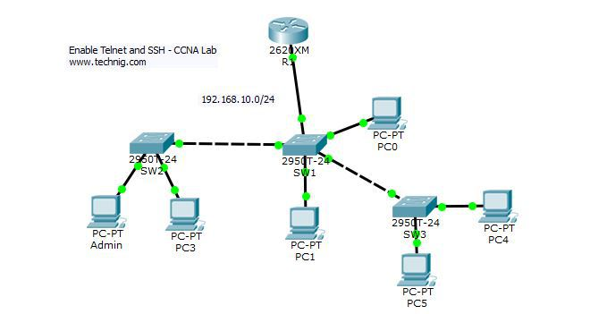

Go to router R1 console and configure telnet with “line vty” command.

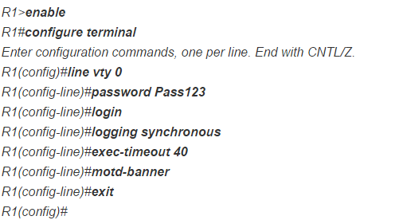

## Command descriptions:

The “**line vty**” command enable the telnet and the “**0″** is just let a single line or session to the router. If you need more session simultaneously, you must type “**line vty 0 10**“.

The “**password**” command set the “**Pass123**” as password for telnet. You can set your own password.

The “**login**” command authenticate and ask you the password of telnet. If you type “**no login**” command, the telnet never authenticate for password which is not a good practice in real network environment.

The “**logging synchronous**” command stops any message output from splitting your typing.

The “**exec-timeout”** command just sets the time-out limit on the line from the default to “**40″**minutes.

The **motd-banner** forces a banner message to appear when logging in.

OK, the Telnet services enabled successfully. But you must set the **enable password**for router in order to control it remotely.

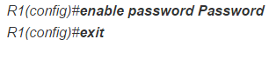

## Testing Telnet Connectivity

Now from a client PC test the telnet connectivity and to insure that it works fine or not yet. If it is not work, try to troubleshoot telnet errors.

Let’s test telnet from the admin PC. Type telnet 192.168.10.1 and press enter, then enter the telnet password. Next type enable command and press enter, then type the router password.

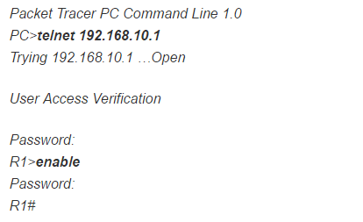

Now you are remotely connected to router R1 and you can execute all router commands through telnet command line interface.

If you need more information about Telnet commands and options, from the **config-line**mode type “**?**“, the question mark will display all telnet commands.

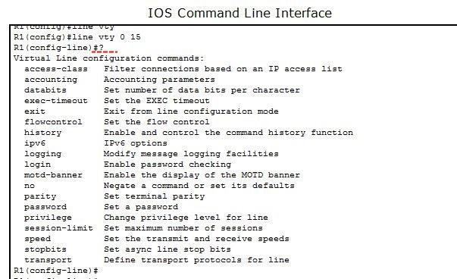

That is it, the telnet services configuration on Cisco router.

## 2. Enable Telnet and SSH: SSH Configuration.

Secure Shell or SSH is a secure protocol and the replacement for Telnet and other insecure remote shell protocols. So for secure communication between network devices, I strongly recommend using SSH instead of Telnet.

Configure SSH on Cisco routers and switches with the below step by step guide to SSH configuration.



1. Open the router R1 console line and create domain and user name.

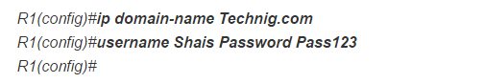

Then “**ip domain-name**” command create a domain and named Technig.com.

The “**username Shais Password Pass123**” command just create a user name “**Shais**” with “**Pass123**” password.

1. If you don, just follow and generate the encryption keys for securing the ssh session.



The name for the keys will be: R1.Technig.com  
Choose the size of the key modulus in the range of 360 to 2048 for your  
General Purpose Keys. Choosing a key modulus greater than 512 may take  
a few minutes.

How many bits in the modulus [512]:***1024***  
% Generating 1024 bit RSA keys, keys will be non-exportable…[OK]

R1(config)#

Type “**crypto key generate rsa**” command and press enter, when ask you “**How many bits in the modulus [512]:**” just type “**1024″** and press enter. The system will generate**1024** bits keys to secure session lines. You can choose modulus in the range of 360 to 2048.

1. Now enable SSH version 2, set time out duration and login attempt time on the router. Remember this message if you going to use ssh version 2 “**Please create RSA keys (of at least 768 bits size) to enable SSH v2.**”

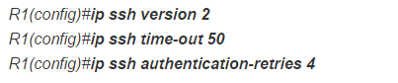

1. Enable vty lines and configure access protocols.

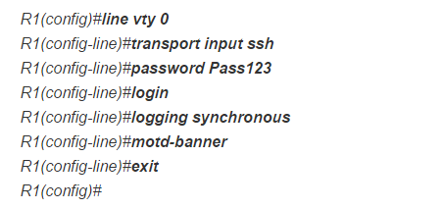

The configuration is the same as telnet, just the**transport input ssh**commandchange the line to**Secure Shell.**Configuration has completed, next you must test ssh from a client PC.

## Testing SSH Connectivity

From a client PC, open the command line and type “**ssh -l Shais 192.168.10.1**” then press enter.

Packet Tracer PC Command Line 1.0

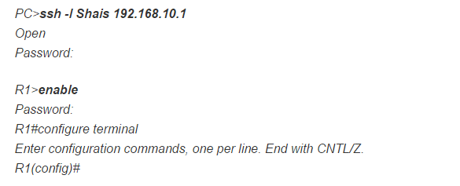

Here, I have connected successfully and the connection is secured with Secure Shell.

Hope you understand the configuration of enable Telnet and SSH on Cisco router and switches. Now you should be able to simply enable Telnet and SSH on your routers and switches.

**CCN Lab 7**

**Computer Communications & Networks**

Building a WAN Between Two LANs

**Step 1** Construct the following topology. Assign all IPs and activate all Fast Ethernet Interfaces.



**Step 2** Then pick up **DCE Serial Cable** and connect the two routers via serial interfaces.

***Note:*** *If Serial Interface not already installed in the routers, we have to manually place* ***WIC-2T*** *module in the routers using* ***Physical Mode.***



**Step 3** Configure Serial interfaces of both the routers, the same as we do Fast Ethernet Interfaces. But IPs assigned to both the serials interfaces should belong to one network and the network should be unique, different from all other LAN or WAN Networks.

**Step 4** Finally, to make the link work, the router with the DCE cable installed must do one function normally done by the CSU/DSU. The CSU/DSU normally provides a function called clocking, in which it tells the router exactly when to send each bit through signaling over the serial cable. A router serial interface can provide clocking, but the router does not do so unless configured with the clock rate command. Clock Rate command is only configured in the router showing clock symbol near its interface.

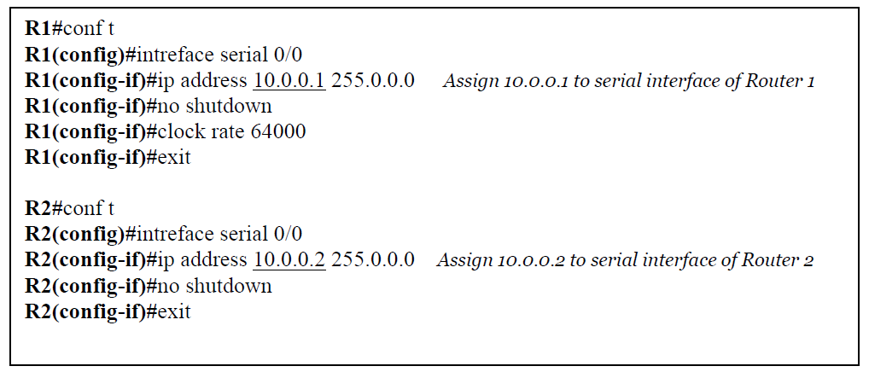

**Step 5** Verify through **show interfaces** or **show ip interface brief**

**TASK 2.1: Accessing Router Remotely via Telnet on TCP Protocol.**

**Step 1** Configure vty password and privilege mode password on Router you want to access remotely.

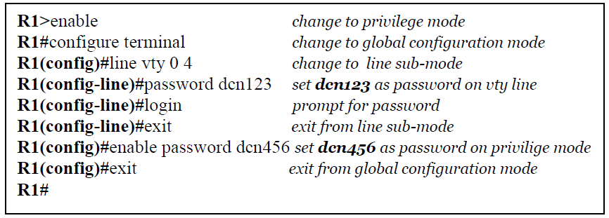

**Step 2 transport input telnet** when configured in configure mode of a router activates telnet on the virtual line.

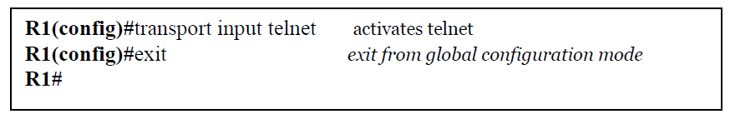

**Step 3** Open Command Prompt Window on one of remote PCs, and type the command **telnet Router IP.** You will be asked vty password. After entering the vty password you will be proceeded to router’s user mode in the same command prompt window.

**CCN Lab 8**

**Computer Communications & Networks**

**Static Routing**

**1. Learning Objectives:**

To understand what is static routing and how to deploy network with static routes.

**2. Equipment Required:**

A working computer having Cisco packet tracer installed.

**3. Introduction:**

**Static routing** is a form of routing that occurs when a router uses a manually-configured routing entry, rather than information from a dynamic routing protocol to forward traffic. In many cases, static routes are usually manually configured by a network administrator by adding in entries into a routing table, though this may not always be the case. Unlike dynamic routing, static routes are fixed and do not change if the network is changed or reconfigured. Static routing and dynamic routing are not mutually exclusive. Both dynamic routing and static routing are usually used on a router to maximize routing efficiency and to provide backups in the event that dynamic routing information fails to be exchanged. Static routing can also be used in stub networks, or to provide a gateway of last resort**.**

Configure Static Routing is the routing that network administrator configure the network routers manually, instead of using routing protocols, RIP or OSPF which used in the dynamic routing. The benefits of static routing is minimum bandwidth usage, no overhead on router CPU and many more and perfect for small network with a few routers. But it is not without cons. Difficult to configure all routers manually in the large network and troubleshooting is always harder than configuration.

As network administrator or student of computer networks you must know the configuration of static routing. It helps you to understand the process and functions of routing in the network clearly.

**Uses:**

Static routing may have the following uses:

* Static routing can be used to define an exit point from a router when no other routes are available or necessary. This is called a default route.
* Static routing can be used for small networks that require only one or two routes. This is often more efficient since a link is not being wasted by exchanging dynamic routing information.
* Static routing is often used as a complement to dynamic routing to provide a failsafe backup in the event that a dynamic route is unavailable.
* Static routing is often used to help transfer routing information from one routing protocol to another (routing redistribution).

**Disadvantages:**

Static routing can have some potential disadvantages:

* **Human Error:** In many cases, static routes are manually configured. This increases the potential for input mistakes. Administrators can make mistakes and mistype in network information, or configure incorrect routing paths by mistake.
* **Fault Tolerance:** Static routing is not fault tolerant. This means that when there is a change in the network or a failure occurs between two statically defined devices, traffic will not be re-routed. As a result the network is unusable until the failure is repaired or the static route is manually reconfigured by an administrator.
* **Administrative Distance:** Static routes typically take precedence over routes configured with a dynamic routing protocol. This means that static routes may prevent routing protocols from working as intended. A solution is to manually modify the administrative distance.
* **Administrative overhead:** Static routes must be configured on each router in the network(s). This configuration can take a long time if there are many routers. It also means that reconfiguration can be slow and inefficient. Dynamic routing on the other hand automatically propagates routing changes, reducing the need for manual reconfiguration.

**IP route command** is used to configure the static route. Static routes are the most secure way of routing. They will also increase overall network performance. These features are extremely helpful in small network.

IP route command and parameters:



## ip route

This is the base command which adds new route in routing table.

## destination_network_#[subnet_mask]

This is the first parameter. It specifies the destination network address. We need to provide subnet mask if we are using sub-network. Sub-networks are the smaller networks created from one large network in subnetting. If we are not using sub-network then we can omit the subnet mask value. It will parse automatically.

## IP_address_of_next_hop_neighbor / interface_to_exit

This parameter provides a way to reach the destination network. Both commands use separate way to assign this value. First command provides the IP address of next hop neighbor. It tells router that if it receives a packet for destination [that we set in previous parameter], forward that packet to this next hop neighbor IP address.

Second command also do the same job but in different way. It specifies exit interface instead of next hop IP address. It tells router that if it receives a packet for the destination specified by previous parameter then exits that packet from this interface. Device attached on other end of this interface will take care of the packet.

## administrative_distance

Administrative distance is the trustworthiness of route. Route with the lowest AD value will be chosen while forwarding the packet. By default static route has two AD values depending on the previous parameter. If you have used next hop neighbor IP address, then the default AD value will be 1. If you have used exit interface, then the default AD value will be 0. This parameter allows us to create multiple static routes for the same destination. For example we can create primary and backup path for the destination network. To create backup path, we need to set AD value to higher than default, such as 2 or 3. With this configuration router will use primary path. Due to some reason if primary route fails, the router will start using backup route automatically.

## Permanent

When a route goes down router will remove that from routing table. Permanent parameter will keep this route in routing table even if it goes down. Its optional parameter we can omit it. If we omit it, router will remove this route from routing table if it goes down. You might use this parameter for security reason if you never want packets to take another path.

## Configure Default Route

By default when a packet arrives in interface, router checks destination filed in packet and compare it with routing table. If it finds a match for destination network then it will forward that packet from related interface. If it does not find a match in routing table then it will discard that packet. This is the default behavior of router. Default route allows us to override this behavior. Default route is a way to deal with all unmatched packets. If no match for destination network found in routing table then it would be forwarded to the default route.

Following command will set default route:



# Task 1:

Create a practice topology as shown in fowling figure.

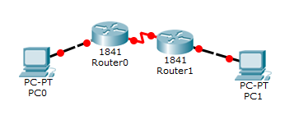

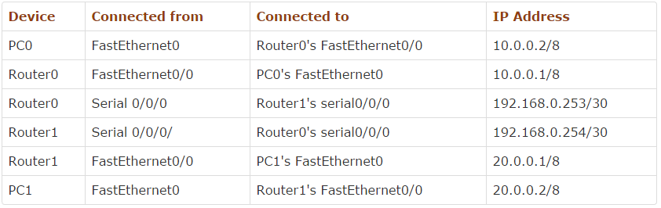

## Assign IP address to devices

Step 1:

Assign IP address 10.0.0.2/8 to PC0.

Step 2:

Repeat same process for PC1 and assign IP address 20.0.0.2/8.

## Assign IP address to interfaces of router

Step 3:

Double click Router0 and click CLI and press Enter key to access command prompt of router.

Step 4:

Two interfaces FastEthernet0/0 and Serial0/0/0 of Router0 are used in this topology. By default interfaces on router are remain administratively down during the start up. We need to configure IP address and other parameters on interfaces before we could actually use them for routing. Interface mode is used to assign IP address and other parameters. Interface mode can be accessed from global configuration mode. Following commands are used to access global configuration mode.

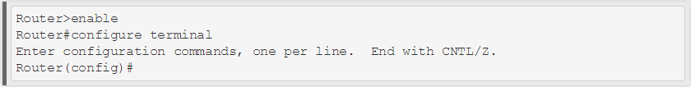

Step 5:

From global configuration mode we can enter in interface mode. From there we can configure the interface. Following commands will assign IP address on FastEthernet0/0.

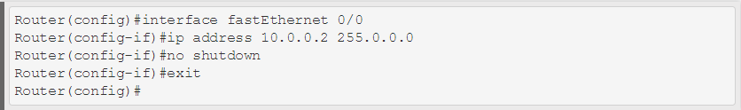

**interface fastEthernet 0/0** command is used to enter in interface mode.

**ip address 10.0.0.2 255.0.0.0** command will assign IP address to interface.

**no shutdown** command will bring the interface up.

**exit** command is used to return in global configuration mode.

Step 6:

Serial interface needs two additional parameters clock rate and bandwidth. Every serial cable has two ends DTE and DCE. These parameters are always configured at DCE end. We can use **show controllers interface** command from privilege mode to check the cable's end.

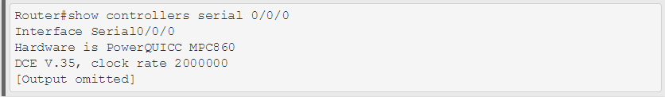

Fourth line of output confirms that DCE end of serial cable is attached. If you see DTE here instead of DCE skip these parameters.

Step 7:

Now we have necessary information let's assign IP address to serial interface.

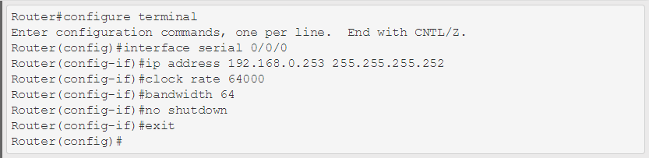

**Router#configure terminal** Command is used to enter in global configuration mode.

**Router(config)#interface serial 0/0/0** Command is used to enter in interface mode.

**Router(config-if)#ip address 192.168.0.253 255.255.255.252** Command assigns IP address to interface. For serial link we usually use IP address from /30 subnet.

**Router(config-if)#clock rate 64000** And **Router(config-if)#bandwidth 64** In real life environment these parameters control the data flow between serial links and need to be set at service providers end. In lab environment we need not to worry about these values. We can use these values.

**Router(config-if)#no shutdown** Command brings interface up.

**Router(config-if)#exit** Command is used to return in global configuration mode.

Step 8:

We will use same commands to assign IP addresses on interfaces of Router1. Since we have provided clock rate and bandwidth on serial interface of Router0 we need not to assign them on serial interface of Router1. Following command will assign IP addresses on interface of Router1.

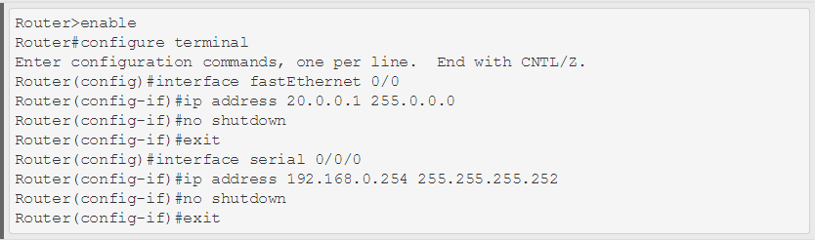

## Configure Static Route

Step 9:

Run following command from global configuration mode in routers.

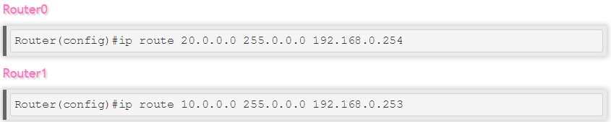

Step 10:

That's all we need to switch packet from one network to another. To verify the result we can use **ping** command. Access the command prompt of **PC1** and use ping command to test the connectivity from **PC0**.

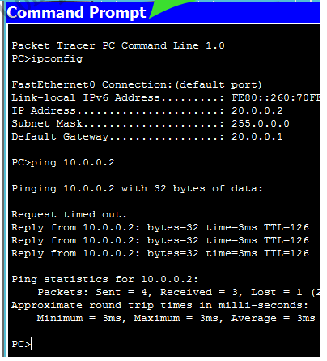

A successful reply indicates that static routing is configured properly.

# Task 2:

Configure Static Routing for below topology.

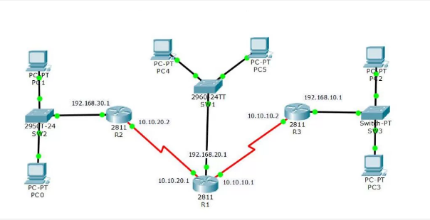

To perform this task you must create your topology and configure the basic IP addressing for all PCs and Routers shown in given figure.

In the **R1** type the following commands to introduce two LANs 192.168.10.0/24 and 192.168.30.0/24 for Router 1.

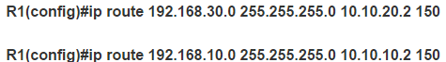

**Router2:** Add three networks for router 2 and be sure that do not configure it with wrong IP address.

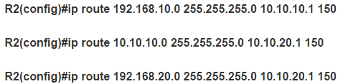

**Router3:** Do the same as router 2 but with different destination and exit interface address.

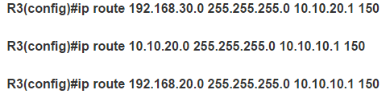

**CCN Lab 9**

**Computer Communications & Networks**

**Networks, IP Addressing Scheme, Subnetting,VLSM & Packet Tracer**

**1. Learning Objectives:**

To become familiar with:

a. IP addresses and IP addressing space

b. Static and dynamic IP addressing

c. Subnetting concept

d. VLSM – Variable Length Subnet masking

e. CIDR -- Classless Inter Domain Routing.

**2. Equipment Required:**

A working computer having Cisco packet tracer installed.

**3. Introduction:**

**What are IP Addresses?**

IP (Internet Protocol) Addresses are used to identify hosts on a network. It is a numerical Representation of the address assigned to each device participating in the network. An IP address serves two important functions:

* Host or network identification
* Location addressing

An IP address is defined by a 32 bit long number. IP addresses are binary numbers usually written as x.x.x.x format where each ‘x’ represents 8 bits or an octet. For example, 192.168.2.56 is a 32 bit valid IP address.

**IP Addressing Space**

The 32 bit length of the IP address limits the addressing space to 4294967296 unique IP addresses (2^32 = 4294967296).

**Static and Dynamic IP Addressing**

As the name suggests, Static IP addressing refers to a fixed IP address for a fixed client whereas the Dynamic IP address assigns a new IP based on available IPs each time the ISP customer logs onto the network.

**Static IP Addressing**

Static IP addressing is more suitable whenever you need to work for Voice over IP (VOIP) protocols or using some Virtual Private Network (VPN) for securing files and data. Static IPs can become a source of security risk as they are easy to track.

**Dynamic IP Routing**

The biggest advantage of Dynamic IP addressing is the fewer security risks as the client is assigned a new IP each time it connects with the network. Dynamic IPs is cost effective and require no special configuration. Dynamic IPs is not recommended while dealing with VOIP setups, VPNs or gaming environments.

**Subnetting Concept**

As described above, Internet Protocol (IP) is a communication protocol used from smallest private network to a massive global network. It is a unique identifier given to each single device on the IP network. IP addresses are written as a combination of 4 octets as ‘X.X.X.X’ whereas an octet is made up of numbers ranging from 0-255. The numbers below show how IP addresses increment:

0.0.0.0

0.0.0.1

...increment 252 hosts...

0.0.0.254

0.0.0.255

0.0.1.0

0.0.1.1

...increment 252 hosts...

0.0.1.254

0.0.1.255

0.0.2.0

0.0.2.1

...increment 4+ billion hosts...

255.255.255.255

**IP CLASSES**

For an arbitrary classification of IP subnets, the network was broken down into multiple classes. The internet is laid out as Class A, B, C, D & E. Class A uses up half of the entire internet; Class B uses up half of the remaining half, Class C uses up half of the remaining half and so on. Class D is used for multi casting and Class E is reserved for future use.

**SUBNET ADDRESSES**

The concept of Subnetting was introduced to further divide a network into sub-networks or smaller networks. Each IP address consists of two parts; **network part and host part**. To differentiate between network part and host par, **subnet masks** are used.

**SUBNET MASK**

The subnet mask plays crucial role in defining the size of a subnet. A subnet mask defines how many bits are used for the network and how many for the host address.

**MASKING**

The subnet mask not only determines the size of a subnet, but it can also help you pinpoint where the end points on the subnet are if you're given any IP address within that subnet. The reason it's called a subnet "mask" is that it literally masks out the host bits and leaves only the Network ID that begins the subnet. Once you know the beginning of the subnet and how big it is, you can determine the end of the subnet, which is the Broadcast ID. To calculate the Network ID, you simply take any IP address within that subnet and run the AND operator on the subnet mask. Let's take an IP address of 10.20.237.15 and a subnet mask of 255.255.248.0. Note that this can be and often is written in shorthand as **10.20.237.15/21** because the subnet mask length is 21.

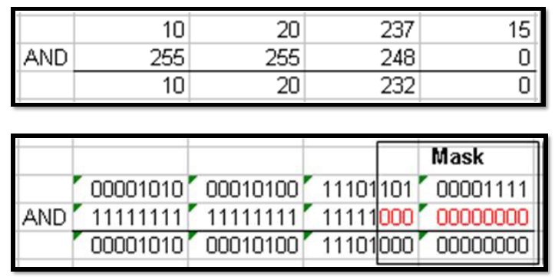

The binary version shows how the **0**s act as a mask on the IP address on top. Inside the masking box, the **0**s convert all numbers on top into zeros, no matter what the number is. When you take the resultant binary Network ID and convert it to decimal, you get 10.20.232.0 as **the Network ID**.

Since there are 11 zeros in the subnet mask, the subnet is 11 bits long. This means there are 2^11, or 2,048, maximum hosts in the subnet and the last IP in this subnet is 10.20.239.255. You could compute this quickly by seeing there are three zeros in the third octet, which means the third octet of the IP address can have a variance of 2^3, or 8. So the next subnet starts at 10.20.232+8.0, which is 10.20.240.0. If we decrease that by 1, we have 10.20.239.255, which is where this subnet ends.

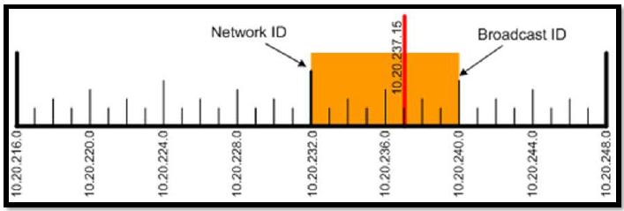

**IMPORTANCE OF SUBNETTING**

Subnetting allows you to create multiple logical networks that exist within a single Class A, B, or C network. If you do not subnet, you are only able to use one network from your Class A, B, or C network, which is unrealistic. Each data link on a network must have a unique network ID, with every node on that link being a member of the same network. If you break a major network (Class A, B, or C) into smaller subnetworks, it allows you to create a network of interconnecting subnetworks. Each data link on this network would then have unique network/subnetworks ID. Any device, or gateway, connecting *n* networks/subnetworks has *n* distinct IP addresses, one for each network / subnetwork that it interconnects.

**(swtich to Lab 7B)**

In order to subnet a network, extend the natural mask using some of the bits from the host ID portion of the address to create a subnetwork ID. For example, given a Class C network of 204.17.5.0 which has a natural mask of 255.255.255.0, you can create subnets in this manner:

204.17.5.0 - 11001100.00010001.00000101.00000000

255.255.255.224 - 11111111.11111111.11111111.11100000

By extending the mask to be 255.255.255.224, you have taken three bits (indicated by "sub") from the original host portion of the address and used them to make subnets. With these three bits, it is possible to create eight subnets. With the remaining five host ID bits, each subnet can have up to 32 host addresses, 30 of which can actually be assigned to a device since host ids of all zeros or all ones are not allowed (it is very important to remember this). So, with this in mind, these subnets have been created.

204.17.5.0 255.255.255.224 host address range 1 to 30

204.17.5.32 255.255.255.224 host address range 33 to 62

204.17.5.64 255.255.255.224 host address range 65 to 94

204.17.5.96 255.255.255.224 host address range 97 to 126

204.17.5.128 255.255.255.224 host address range 129 to 158

204.17.5.160 255.255.255.224 host address range 161 to 190

204.17.5.192 255.255.255.224 host address range 193 to 222

204.17.5.224 255.255.255.224 host address range 225 to 254

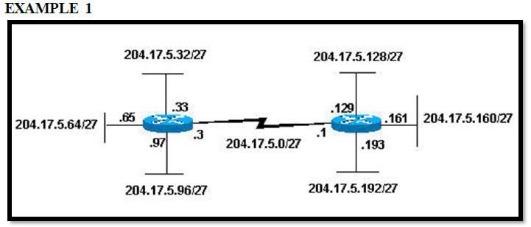

Notice that each of the routers in Figure above is attached to four subnetworks, one subnetwork is common to both routers. Also, each router has an IP address for each subnetwork to which it is attached. Each subnetwork could potentially support up to 30 host addresses.

This brings up an interesting point. The more host bits you use for a subnet mask, the more subnets you have available. However, the more subnets available, the less host addresses available per subnet. For example, a Class C network of 204.17.5.0 and a mask of 255.255.255.224 (/27) allows you to have eight subnets, each with 32 host addresses (30 of which could be assigned to devices). If you use a mask of 255.255.255.240 (/28), the break down is:

204.17.5.0 - 11001100.00010001.00000101.00000000

255.255.255.240 - 11111111.11111111.11111111.11110000

Since you now have four bits to make subnets with, you only have four bits left for host addresses. So in this case you can have up to 16 subnets, each of which can have up to 16 host addresses (14 of which can be assigned to devices).

# Example

<http://www.computernetworkingnotes.com/ccna-study-guide/vlsm-tutorial-with-examples.html>

**VLSM and CIDR**

The ability of routing protocols to route to networks with Variable Length Subnet Masks (VLSM) and Classless Interdomain Routing (CIDR), along with the creation of **NAT** and private addressing, has enabled IPv4 to remain a viable network address solution well beyond its original design limitations. When IPv4 addressing was first developed it was designed as a class based system with Class A, B, C, D, E addresses. This class based system was divided into networks and hosts based on a net mask system with the following class-based net masks:

Class A: 255.0.0.0 (255 network addresses and 16,777,216 hosts)

Class B: 255.255.0.0 (65,536 network addresses and 65,536 host addresses)

Class C: 255.255.255.0 (16,777,216 network addresses and 256 host addresses)

If every computer on the internet needed a public IP address we would have run out of IPv4 addresses a long time ago. The development of **VLSM and CIDR, NAT, and Private Addressing** helped the conservation of IPv4 addresses that was brought about by the need to deal with the exponential growth of the internet and the realization that IPv4 was simply running out of address space. Since then, IPv4 address space has indeed run out, and IPv6 has been developed which will never run out, but VLSM, CIDR, NAT, and private addressing enabled IPv4 to last much longer than expected and because of those developments IPv4 is still very much in use today.

**Implementation**

CIDR basically means that when routing you are not limited to networks based on /8, /16, or /24 subnet masks, and VLSM means that as long as the address spaces do not overlap, you can divide a classful network like 192.168.1.0 /24 into networks of different sizes and subnet masks like this:

192.168.1.0 /24 (1 network with 256 hosts)

or in the example below, 7 networks of different sizes

192.168.1.0 ..to.. 192.168.1.127 /25 (1 network with 128 hosts),

192.168.1.128 ..to.. 192.168.1.191 /26 (1 network with 64 hosts),

192.168.1.192 ..to.. 192.168.1.223 /27 (1 network with 32 hosts),

192.168.1.224 ..to.. 192.168.1.239 /28 (1 network with 16 hosts),

192.168.1.240 ..to.. 192.168.1.247 /29 (1 network with 8 hosts),

192.168.1.248 ..to.. 192.168.1.251 /30 (1 network with 4 hosts),

192.168.1.252 ..to.. 192.168.1.255 /30 (1 network with 4 hosts)

**Summary Routes and Supernets**

With CIDR and classless addressing, not only can you divide subnets into smaller subnets you can also generalize or summarize subnets into ***SUPERNETS***. A ***SUPERNET*** allows a router to put one summary route in its routing table instead of many routes. Take the following example:

Let's say you have a router that is connected to another router that has the following connected networks:

192.168.0.0 /24

192.168.1.0 /24

192.168.2.0 /24

192.168.3.0 /24

192.168.4.0 /24

..to..

192.168.15.0 /24

Instead of configuring 16 static routes to reach all of those networks you could configure one supernet route of 192.168.0.0 /16 thus basically saying, all of the 192.168 networks are over there! Of course, if in fact it is only networks 192.168.0 through 192.168.15 then a more correct supernet route would be 192.168.0.0 /20 which says: networks 192.168.0.0 through 192.168.15.0 are over there, because the /20 subnet mask has a magic number of 16, and networks 192.168.16 and up, are not in the range being summarized.

**LAB EXERCISES**

**Exercise 01:**

Given the Class C network of 204.15.5.0/24, subnet the network in order to create the network in Figure shown above, with the host requirements shown. Implement the scheme in Cisco Packet Tracer.

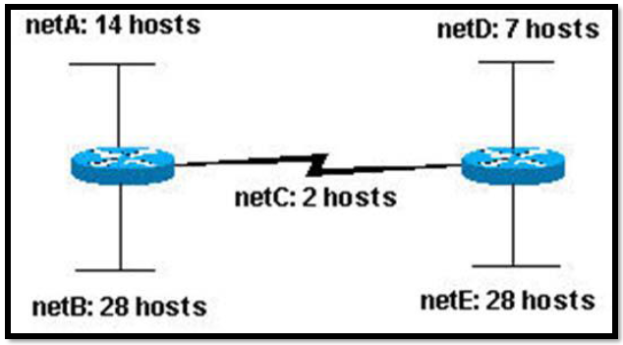

**Exercise 02:**

Use VLSM techniques to implement the following network in Packet Tracer. Use static routes between routers to make routing tables. Use 192.168.1.0/24 as the parent network.

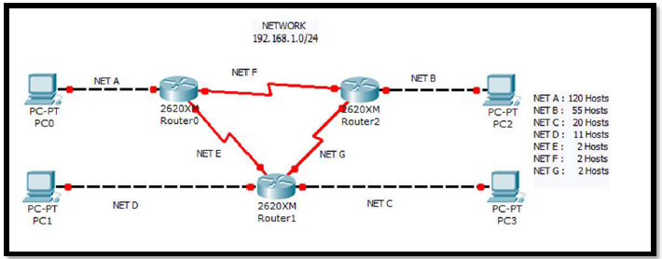

**CCN Lab 10**

**Computer Communications & Networks**

IP Addressing Scheme & VLSM

**Classful network** is a term used to describe the network architecture of the Internet until around 1993. It dividedthe address space for Internet Protocol Version 4 (IPv4) into five address classes.

**Each class, coded by the first three bits of the address**, defined a different size or type (unicast or multicast) of the network.

All networks in practical use have different sizes.

For example, a company that will have 50 computers, will not need a network of 5000 computers, And on the contrary, a company that needs 5000 computers does not need a network that can only hold 50 computers. This is the main reason that engineers decided that IP address space should be divided in different classes in order to meet different requirements.

This addressing scheme is illustrated below.

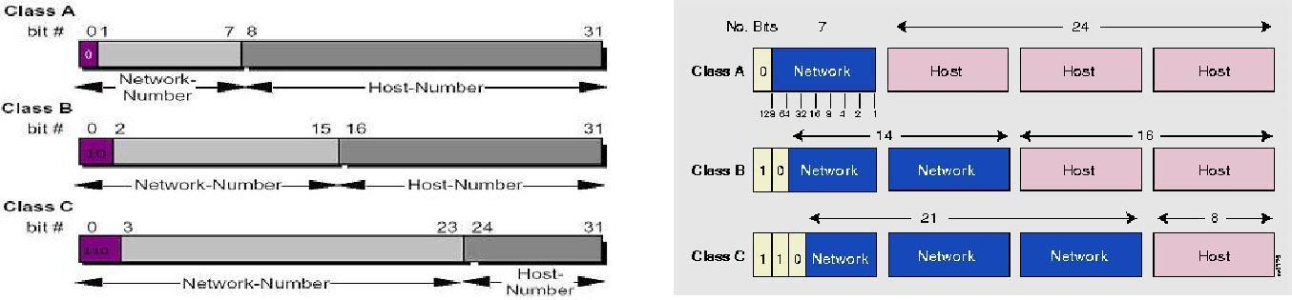

**Class A Network (/ 8 Prefixes)**

This network is 8-bit network prefix. Its highest bit is set to 0, and contains a 7-bit network number and a **24-bit** **host number**.

A maximum of **126, which is (2** **7** **-2,) networks can be defined**; two is subtracted because all an (0 and 1) subnet cannot be used in certain routers using **RIP-1 Protocol**. Each network supports a maximum of 16,777,214 (2 24 -2) hosts per network. You must subtract two because the base network represents host “0”, and the last host on the network is actually used for 1s ("broadcast") and may not be assigned to any host.

The class **A** network address block contains 2 31 power (2,147,483,648) individual addresses. The IPv4 address

space contains a maximum of 2 32 power (4,294,967,296) addresses, which mean that a class **A** network address space is 50% of the total IPv4 unicast, address space.

**Class B Networks (/16 Prefixes)**

This network is a 16-bit network prefix; its highest bit order is set to **1-0**. It is a 14-bit network number with a 16-bit host number.

This class defines 16,384 (2 14) /16 networks, and supports a maximum of 65,534 (2 16 -2) hosts per network. Class B /16 block address is (1,073,741,824) = 2 30; therefore it represent 25% of the total IPV4.

**Introduction to Subnetting**

**Purpose:**

The lab is intended to familiarize the students with a networking technique of SUBNETTING.

At the end of the lab the student must know:

1. The Purpose of SUBNETTING.

2. Steps of SUBNETTING.

3. How to perform SUBNETTING on different IP Classes.

4. Calculating the ranges of Hosts in the Subnet.

5. Finding the Broadcast address of the Subnet.

6. How to make a SUBNET on Linux machines.

7. How to Broadcast on that Subnet.

**Subnetting:**

In subnetting, a network is divided into smaller subnets with each subnet having its own subnet address.

**Reasons for Subnetting**

* Imagine a Network Class A with over 16 millions of hosts or a Class B Network with 65 thousand hosts, it is impractical.
* Most IP address assignments were not used very efficiently.
* Broadcast problem.
* Many sites were requesting multiple network numbers due to variable amounts of networks at their sites.

**Benefits of subnetting**

* Reduced network traffic
* Simplified management
* Smaller broadcast domains

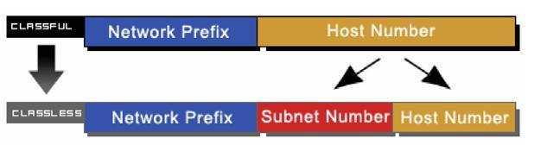

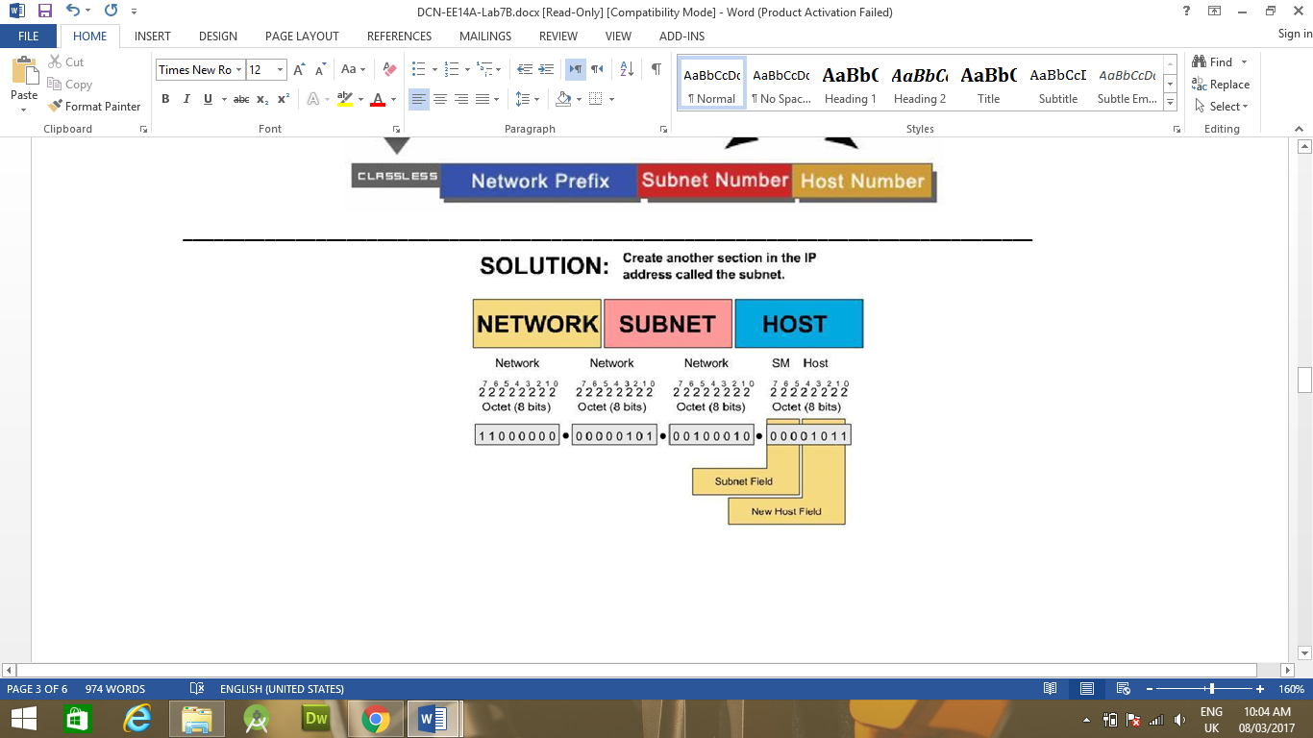**Network before Subnetting**

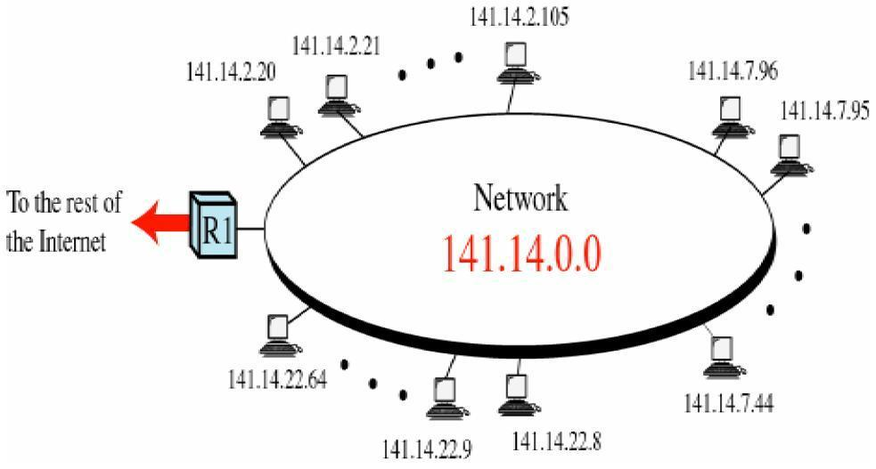

**Network after Subnetting**

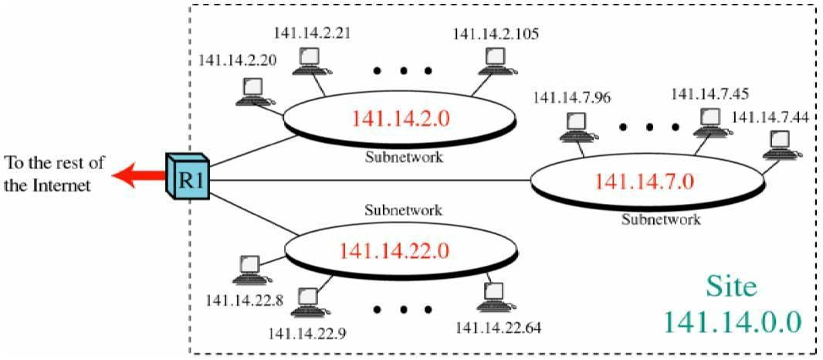

**SUBNETTING:**

The purpose of subnetting is that by using only one given IP we can make different networks.

E.g. If the Given IP is: 172.16.0.0 and we are required to make 169 Subnets, then, by using the following formula for subnets we can find the no. of bits required for the subnets:

**2n – 2 >= No. of Subnets.**

Where ‘n’ is No. of Bits further required as network address field in the given IP.

Therefore for 169 subnets we get n = 8. So the new mask becomes: 255.255.255.0

First subnet IP address: 172.16.1.0

First PC IP address in this Subnet: 172.16.1.1

Last PC IP address in this Subnet: 172.16.1.254

Broadcast IP address in this Subnet: 172.16.1.255

Last subnet IP address: 172.16.254.0

First PC IP address in this Subnet: 172.16.254.1

Last PC IP address in this Subnet: 172.16.254.254

Broadcast IP address in this Subnet: 172.16.254.255

**Default Subnet mask**

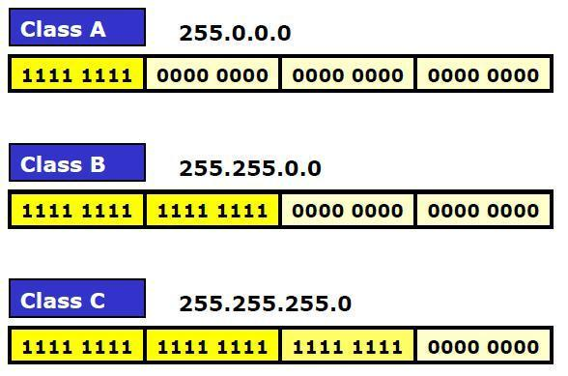

**Masking**

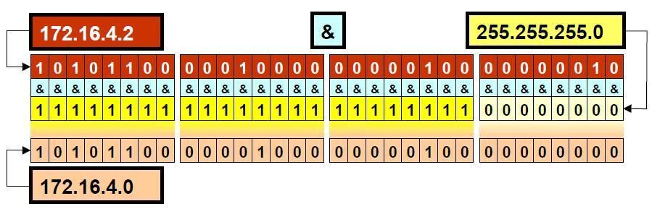

**Task1:**

For The following IPs find the first two and last two Subnets and give their Pc range and Broadcast address.

1. 10.0.0.0 for 1025 subnets.
2. 212.31.30.0 for 21 subnets.
3. 190.38.0.0 for 645 subnets.

**Task2:**

Implement first two subnets created in Task (1-2) in Packet Tracer.

**CCN Lab 11**

**Computer Communications & Networks**

Subnetting Questions with Detailed Answers

These questions were designed to test your knowledge of subnetting. Hopefully, by the end of the worksheet, the exercise will make you feel more comfortable with your ability to subnet ip addresses. Do not use a calculator for these problems, and please show your handwritten work on these questions.  
  
1. You work for a large communications corporation named GlobeComm which has been assigned a Class A network address. Currently, the company has 1,000 subnets in offices around the world. You want to add 100 new subnets over the next three years, and you want to allow for the largest possible number of host addresses per subnet.  
  
Which subnet mask would you choose?  
  
*Answer:255.255.224.0  
  
Requirements: 1,000 subnets + 100 subnets = 1,100 subnets, and as many host addresses as possible  
2^10-2 = 1022 we Know from memory that 2^10= 1024, and will yield ONLY 1022 usable subnets with 10 bits of subnetting  
Because our requirements ask for over 1024 subnets, we must borrow one more host bit for our subnetting:  
2^11-2 = (1024 * 2) - 2 = 2046 unique usable subnets  
  
11111111 00000000 00000000 00000000 = 255.0.0.0 Default class A subnet mask  
11111111 11111111 11100000 00000000 = 255.255.224.0 Default Class A subnet mask with our 11 bits of subnetting  
  
  
2. Which of the following is a valid IP host address given the network ID of 191.254.0.0 while using 11 bits for subnetting?  
a. 191.254.0.32  
b. 191.254.0.96  
c. 191.254.1.29  
d. 191.54.1.64  
  
*Answer: Choice C is correct: 191.254.1.29. The network ID 191.254.0.0 is a Class B network address with a default subnet mask of 255.255.0.0. Adding 11 subnetting bits to the default 16-bit subnet mask yields 27 subnet bits and makes the new subnet mask 255.255.255.224. Using 11 bits for subnetting provides 2046 subnets with a maximum of 30 hosts per subnet. To fin the subnet address interval, use the following procedure. Convert the subnet mask 255.255.255.224 into binary. Next, convert the lowest order subnet bit to decimal. In this item, the decimal value of the lowest-order non-zero bit is 32. Use the decimal value of the lowest-order bit as the interval for calculating subnet IDs. The following table displays the host ID ranges for the first 10 subnets.  
  
Subnet ID Host ID Range  
191.254.0.0 191.254.0.1 -191.254.0.30  
191.254.0.32 191.254.0.33 -191.254.0.62  
191.254.0.64 191.254.0.65 -191.254.0.94  
191.254.0.96 191.254.0.97 -191.254.0.126  
191.254.0.128 191.254.0.129-191.254.0.158  
191.254.0.160 191.254.0.161-191.254.0.190  
191.254.0.192 191.254.0.193-191.254.0.222  
191.254.0.224 191.254.0.225-191.254.0.254  
191.254.1.0 191.254.1.1 -191.254.1.30  
191.254.1.32 191.254.1.33 -191.254.1.62  
...  
As shown in the table, the IP addresses 191.254.0.32, 191.254.0.96 and 191.254.1.64 are subnet IDs in this scenario. Therefore, these IP addresses cannot be used as host IDs, given a network ID of 191.254.0.0 with 11 bits of subnetting.  
3. NuTex Corporation has been assigned the Class B network address 165.87.0.0. NuTex needs to divide the network into eight subnets. What subnet mask should be applied to the network to provide the most hosts per subnet?  
  
a. 255.255.192.0  
b. 255.255.224.0  
c. 255.255.240.0  
d. 255.255.248.0  
  
*Answer: 255.255.240.0  
2^3-2 = 6 subnets  
2^4-2 = 14 subnets  
(2^16 - 2^4) -2 = 2^12 - 2 = 4094 hosts possible per subnet  
  
Because 3 bits of subnetting will only yield 6 usable subnets (7 if ip subnet-zero is enabled), you will need to borrow another bit. To meet your minimum requirement of 8 subnets, and the maximum number of hosts per subnet, this Subnet mask will be correct: 255.255.240.0  
  
  
4. What is the network ID portion of the IP address 191.154.25.66 if the default subnet mask is used?  
  
Answer: 191.154 - If the default subnet mask is used, then the network ID portion of the IP address 191.154.25.66 is 191.154. The first octet, 191, indicates that this is a class B address. In a class B address, the first two octets of the address represent the network portion. The default subnet mask for a Class B network address is 255.255.0.0. If a network administrator had implemented a subet mask other than the default, then the network portion of the address would be different. For example, an address of 191.154.25.66 with a subnet mask of 255.255.255.0 would have a network ID of 191.154.25.  
  
A Class A address has a default subnet mask of 255.0.0.0; therfore, the first octet of a Class A address represents the network portion of the address, if the default subnet mask is used. A Class C address has a default subnet mask of 255.255.255.0; therefore the first three octets of a Class C address represent the network portion of the network portion of the address, if the default mask is used. The bits to the right of the network portion of an IP address are the host portion of the address.  
  
10111111.10011010.00011001.01000010 = 191.154.25.66 IP address  
11111111.11111111.00000000.00000000 = 255.255.0.0 Default Class B Subnet mask  
10111111.10011010.00000000.00000000 = 191.154.0.0 Network ID is the Result of ANDing the IP address and Subnet mask  
  
  
5.Your company has the network ID 165.121.0.0. You are responsible for creating subnets on the network, and each subnet must provide at least 900 host IDs.  
  
What subnet mask meets the requirement for the minimum number of host IDs and provides the greatest number of subnets?   
  
*Answer: A Class B address with a subnet mask of 255.255.252.0 creates 62 subnets with 1,022 hosts each. The next largest subnet creates 126 subnets, but each subnet contains only 510 hosts. In binary format, the subnet mask reads as: 11111111 11111111 11111100 00000000. The third octet designates 1s for the first 6 digits. The 1s mask the subnet IDs. The calculation of the number of host IDs available for each subnet is based on the number of digits remaining in the network address after all of the subnets are created. To calculate the number of host IDs, raise 2 to the tenth power and then subtract 2. Note that there are two digits remaining in the third octet and eight digits in the fourth octet (00 00000000); these ten digits can be used to create host IDs. The two host IDs that are subtracted are the two host IDs that contain all 0s and all 1s; those IDs identify the subnet itself and the broadcast address for all hosts on the subnet, respectively. The number of possible host IDs in each subnet ranges from 00 00000001 through 11 11111110. Converted to decimal notation, this range is 0.1 through 3.254. For example, in the network 165.121.0.0/22, host addresses can range from 165.121.0.1 through 165.121.3.254.  
  
  
6. What is the broadcast address on subnet 32 given a prefix notation of 12.1.0.0/12?  
a. 12.32.0.1   
b. 12.32.0.255  
c. 12.23.255.255  
d. 12.47.255.255  
  
*Answer: Choice d is correct. Given a prefix notation of 12.1.0.0/12, the broadcast address on subnet 32 is 12.47.255.255. A prefix notation of /1 indicates a binary subnet mask of 11111111 11110000 00000000 00000000 or 255.240.0.0 in dotted-decimal notation. The subnet mask 255.240.0.0 contains 12 masked bits. The address 12.1.0.0 belongs to a Class A network address. When only one octet is used for subnetting, the interval between valid subnets can be determined by subtracting the value of the octet from 256, such as 256 - 240 = 16 in this scenario. The number 16 is both the first valid address of the subnet ID and the interval between valid subnets. Therefore, the first valid subnet ID is 12.16.0.0. Adding 16 to the first subnet ID value yields the second valid subnet, which is subnet 32, and the corresponding IP address for this subnet ID is 12.32.0.0. Continuing this process, the third subnet ID is 12.48.0.0 and so on. The broadcast address for subnet 32 is represented by 00001100 00101111 11111111 11111111 in binary or 12.47.255.255 in dotted-decimal notation. In the second octet of the broadcast address forsubnet 32, the first 4 bits are used for the subnet ID (0010), and 00100000 represents subnet 32. The broadcast address on subnet 32 is found by assigning 1s to each of the 20 rightmost bits that represent the host portion of the address. Exhibit 1 in this explanation shows the addresses and masks involved in this scenario.  
  
The broadcast mask is formed by using 0s for the subnet bits and 1s for the host bits. In this example, network 12.1.0.0/12 uses 12 network bits. Therefore, the first 12 bits of the broadcast mask will be 0s. The remaining 20 bits from the total of 32 bits will be 1s. This yields 00000000 00001111 11111111 11111111 in this example. The broadcast address is calculated by performing a Boolean XOR operation on subnet 32 and the broadcast mask. A Boolean XOR operation compares two bits.   
  
A Boolean XOR operation evaluates to True(1) only when one bit is True and the other bit is False (0). All other combinations result in False, such as when both bits are True or both bits are False. To do the complete XOR operation in this item, first write down the sugnet address in binary. On a second line, write down the broadcast mask. Finally, perform a Boolean XOR operation on all corresponding bits.   
  
00001100.00000001.00000000.00000000 = 12.1.0.0 network address  
11111111.11110000.00000000.00000000 = 255.240.0.0 subnet mask  
00001100.00010000.00000000.00000000 = 12.16.0.0 subnet 16  
00001100.00100000.00000000.00000000 = 12.32.0.0 subnet 32  
00001100.00110000.00000000.00000000 = 12.48.0.0 subnet 48  
00000000.00001111.11111111.11111111 = 0.15.255.255 broadcast mask  
  
00001100.00100000.00000000.00000000 = 12.32.0.0 subnet 32  
00000000.00001111.11111111.11111111 = 0.15.255.255 broadcast mask  
00001100.00101111.11111111.11111111 = 12.47.255.255 subnet 32 Broadcast address  
  
Thus, the XOR operation yields the subnet 32 broadcast address of 12.47.255.255. Note that the sum of the network subnet mask and the network broadcast mask is always 11111111 11111111 11111111 11111111 in binary, or 255.255.255.255 in dotted decimal notation.  
  
  
7. Your ISP has provided you a T1 connection to their network. They have provided the interface at your end of the Serial connection an IP address of 16.32.96.109/30. For this particular situation, you must supply the IP address of the ISP's interface at the opposite end of the serial connection as your Gateway of Last Resort. What IP address would you specify as the Gateway of last resort?  
  
  
Hints(Please answer)  
a. How many hosts are allowed in each subnet? Answer: 2 usable hosts  
32 possible bits in an IP version 4 IP address.  
32 - 30 = 2 possible bits left for our host  
2^2-2 = 2 usable hosts  
  
b. What is the Broadcast address for this network? (Please show the "interesting" octet in binary)  
c. What is the Network address for this network? (Please show the "interesting" octet in binary)  
  
128 64 32 16 8 4 2 1  
0 1 1 0 1 1 0 1 = 109 decimal  
  
16.32.96.01101101 = 16.32.96.109 -IP address of one of your hosts in this small subnet  
255.255.255.11111100 = 255.255.255.252 -Subnet Mask given in CIDR /30  
16.32.96.01101100 = 16.32.96.108 -Network ID for this subnetwork  
16.32.96.01101111 = 16.32.96.111 -Subnet broadcast address  
16.32.96.01101110 = 16.32.96.110 -The only usable host address left range between the network and broadcast  
  
8. You are a network administrator, seated at a workstation at the remote end of a campus network. You are attempting to troubleshoot a communication problem between that client workstation and the server at the other end of campus. This workstation has a static IP address of 181.197.187.212, with a subnet mask of 255.255.224.0. Because a particularly thorough security administrator, Frank, has removed most extraneous applications, including the Calculator, you must use paper and pencil to verify that the workstation is on the same subnet as your server at 181.197.143.236, with a subnet mask of 255.255.224.0. The user reports that the computer "hasn't worked right since it was installed last week." You cannot ping the server from the workstation. Are these two computers on the same subnet?  
  
Answer: NO, see solution below...  
  
Hint- Convert the "interesting octet" of the Subnet mask, of the workstation and then the server to binary. What are the results with dotted-decimal from the boring octets, combined with Binary for the interesting octet? Line them up, how do they compare?  
  
What is the network ID for the Workstation's IP address? (Please show the interesting octet in binary)  
What is the broadcast ID for network? (Please show the interesting octet in binary)  
How many usable host addresses are available for the network?  
  
Interesting Octet = 187 Convert to binary:  
>=128 1  
187-128=59  
>=64 0  
>=32 1  
59-32=27  
>=16 1  
27-16=11  
>=8 1  
11-8=3  
>=4 0  
>=2 1  
3-2=1  
>=1 1  
  
181.197.10111011.212 = 181.197.187.212 -Workstation's configured IP Address   
255.255.11100000.0 = 255.255.224.0 -Workstation's configured Subnet Mask   
181.197.10100000.0 = 181.197.160.0 -Workstation's Network ID   
181.197.10100000.1 = 181.197.160.1 -First Host in Workstation's Range  
...  
181.197.10111111.254 = 181.197.191.254 -Last Host in Workstation's Range   
181.197.10111111.255 = 181.197.191.255 -Workstation's Broadcast ID   
  
...96-128-160-192-224-256 -Network IDs for a 224 Subnet Mask   
  
Interesting Octet = 143 Convert to binary:  
>=128 1  
143-128=15  
>=64 0  
>=32 0  
>=16 0  
>=8 1  
15-8=7  
>=4 1  
7-4=3  
>=2 1  
3-2=1  
>=1 1  
  
  
181.197.10001111.236 = 181.197.143.236 -Server's configured IP address   
255.255.11110000.0 = 255.255.240.0 -Server's configured Subnet Mask  
181.197.10000000.0 = 181.197.128.0 -Server's Network ID  
181.197.10000000.1 = 181.197.128.1 -First Host in Server's Range  
...  
181.197.10001111.254 = 181.197.143.254 -Last Host in Server's Range   
181.197.10001111.255 = 181.197.143.255 -Server's Broadcast ID   
  
...96-112-128-144-160-176-192-208-224... -Subnet ID's for 240 Subnet Masks  
  
If you are at the Workstation, and attempt to ping the server, the workstation must determine whether the server's IP address is on the same subnet as it's own. If the workstation determines that the server is on it's subnet, then it will send an ARP request for the server's IP address, otherwise, the workstation will need to Arp it's configured Default Gateway, because it handles all requests for addresses outside the local subnet, and might have a route to those other networks.  
  
The Workstation must determine if the resource is on the local network or not, and must perform an ANDing operation.  
Workstation's question: Is this destination network address local to my subnet?  
Workstation knows that 181.197.160.0 is it's network ID, and must determine if the server is on that same subnet by ANDing the Server's IP address against it's own Subnet Mask.  
  
181.197.10100000.0 = 181.197.160.0 -Workstation's Network ID   
181.197.10000000.0 = 181.197.128.0 -Server's Network ID   
* -These two network ID's not exactly the same, off by one bit (32)  
Therefore, the Workstation knows the server isn't on an attached network,  
Send packet to my Default Gateway, let it handle packets destined for other networks.  
  
Which of the following might correct a problem like this?  
Change the subnet address of the workstation to 255.255.248.0?   
  
Answer: No, You know this would make the create more subnets, when you would need fewer subnets with larger ranges.  
181.197.10111011.212 = 181.197.187.212 -Workstation's configured IP Address   
255.255.11111000.0 = 255.255.248.0 -Testing 248 Subnet Mask   
181.197.10111000.0 = 181.197.184.0 -New Subnet ID  
181.197.10111111.255 = 181.197.191.255 -Same Broadcast ID as configured, but subnets are increments of 8  
  
Change the entire network's subnet mask to 255.255.240.0?   
  
Answer: No, You would still be on different subnets, but changing the network's subnet mask to 255.255.192.0 would allow these two IP addresses to be on the same subnetwork. This might be a great deal of work, but you can see that creating fewer subnets will make those usable subnets have a broader range.  
  
181.197.10001111.236 = 181.197.143.236 -Server's configured IP address   
255.255.11110000.0 = 255.255.240.0 -Testing 240 subnet mask  
181.197.10000000.0 = 181.197.128.0 -Server's Network ID with 240 subnet mask  
181.197.10111011.212 = 181.197.187.212 -Workstation's configured IP Address   
255.255.11110000.0 = 255.255.240.0 -Testing 240 subnet mask  
181.197.10110000.0 = 181.197.176.0 -Workstation's Network ID with 240 subnet mask  
  
181.197.10000000.0 = 181.197.128.0 -Server's Network ID with 240 subnet mask  
181.197.10110000.0 = 181.197.176.0 -Workstation's Network ID with 240 subnet mask  
** -These two network ID's are still on different subnets, even if both are on 240 subnet mask  
  
Just for an Example, look what happens if you change the network's Subnet mask to 255.255.192.0:  
There are 4 Unique Subnets created, only 2 are Usable.  
  
181.197.10000000.0 = 181.197.128.0 -Server's Network ID with 192 subnet mask  
181.197.10000000.0 = 181.197.128.0 -Workstation's Network ID with 192 subnet mask  
  
Change the IP address of the server?   
  
Answer, this was a tricky question, and there were many ways to answer this one. If you changed the IP Address and Subnet Mask for the server, then you would be able to place the server on the same subnet as the Workstation. The question only mentioned two computers on the network, so changing the server's IP address might not impact anyone else. There is also the possibility that the Server is handling thousands of clients, and changing the IP address might cause the server to become unreachable.  
If you gave the server an IP address of 181.197.187.213/20, then the two devices would be able to communicate.  
  
  
181.197.10111011.212 = 181.197.187.212 -Workstation's configured IP Address   
255.255.11100000.0 = 255.255.224.0 -Workstation's configured Subnet Mask   
181.197.10100000.0 = 181.197.160.0 -Workstation's Network ID  
181.197.10111011.213 = 181.197.187.213 -Server's New Address   
255.255.11110000.0 = 255.255.240.0 -Server's New Subnet Mask   
181.197.10110000.0 = 181.197.160.0 -Server's New Network ID  
  
Interestingly enough, these two machines should be able to communicate on the same physical network, even with different subnet masks.  
This is due to the fact that the workstation will first check to see if the server is on it's subnet.  
Workstation:  
255.255.11100000.0 = 255.255.224.0 -Workstation's configured Subnet Mask  
181.197.10111011.213 = 181.197.187.213 -DESTINATION IP Address  
181.197.10100000.0 = 181.197.160.0 -Result of ANDing the Destination Address,  
Workstation determines that this destination is on it's own network, and ARP's for the Server's MAC address.  
Workstation then initiates an ICMP Echo Request to the server.

Server:  
255.255.11110000.0 = 255.255.240.0 -Server's configured Subnet Mask  
181.197.10111011.212 = 181.197.187.212 -DESTINATION IP Address  
255.255.10110000.0 = 181.197.176.0 -Result of ANDing the Destination Address,   
Server Determines that the Workstation is on it's same network, and sends an Echo Reply.  
Reference:

<http://academic.keystone.edu/cisco/documents/subnetting/SubnettingQuestionsAndAnswers.htm>

**CCN Lab 12**

**Computer Communications & Networks**

## Routing Information Protocol (RIP)

# Learning Objectives:

To become familiar with:

* 1. Routing Information Protocol (RIP).
  2. Implementation of RIP using CISCO Packet Tracer.
  3. Practice problems.

# Equipment Required:

A working computer having Cisco packet tracer installed.

# Introduction:

## Basic Operation of RIP Protocol

RIP is a routing protocol which exchanges network information between routers dynamically. It uses broadcast to share routing information.

Routers aware only about the networks those are directly connected with them. For example in following network R1 only aware about the 10.0.0.0/8 and 192.168.1.252/30 network.

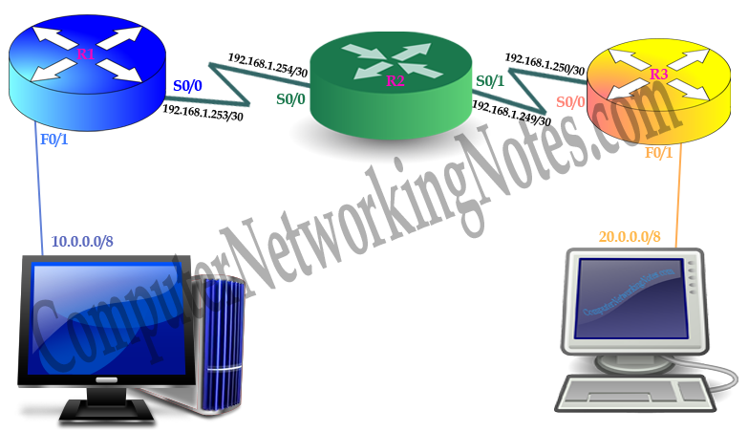

So if it receives a packet for 20.0.0.0/8 from 10.0.0.0/8 network on F0/1 port, it will drop that packet. This is the default behavior of router. By default routers are configured to drop all unmatched packets.

Router can learn about the remote network in two ways; **static and dynamic**.

In static method we have to update router manually. In dynamic method router will be updated by a routing protocol.

In dynamic method this process is done by a routing protocol. Several routing protocols are available to choose from such **RIP, OSPF, IGRP and EIGRP**. In this lab we will explain RIP routing protocol.

## RIP Routing Protocol

In RIP protocol routers learn about the destination networks from neighboring routers through the sharing process. Routers running RIP protocol periodically broadcast the configured networks from all ports. Listing routers will update their routing table based on this information.

Let’s see how RIP process works step by step.

Following figure illustrate a simple network running RIP routing protocol.

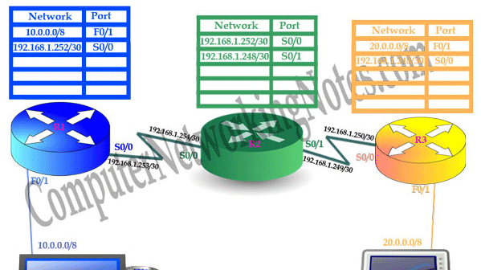

When we start this network, Routers are aware only about the directly connected network.

R1 knows that network **10.0.0.0/8** is connected on **F0/1** port and network **192.168.1.252/30** is connected on **S0/0** port.

R2 knows that network **192.168.1.252/30** is connected on **S0/0** port and network**192.168.1.248/30** is connected on **S0/1** port.

R3 Knows that network **20.0.0.0/8** is connected on **F0/1** and network **192.168.1.248/30** is connected **S0/0** port.

Unlike static routing where we have to configure all routes manually, in dynamic routing all we need to do is just tell the routing protocol which route we want to advertise. And rest will be done automatically by running dynamic protocol. In our network we are running RIP routing protocol so it will be handled by RIP.

Sometime RIP is also known as *routing by rumor*. Because in this routing protocol routers learn routing information from directly connected neighbors, and these neighbors learn from other neighboring routers.

RIP Protocol will share configured routes in network through the broadcasts. These broadcasts are known as **routing updates**. Listening routers will update their routing table based on these updates.

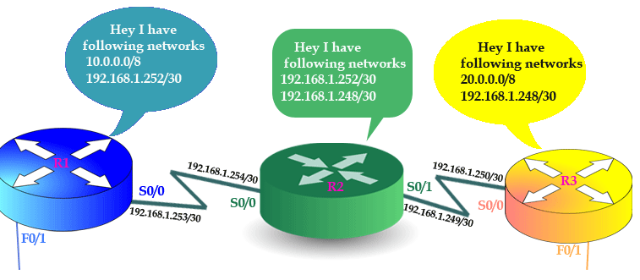

R1 will listen broadcast from R2. From R2 it will learn one new network 192.168.1.248.

R2 will listen two broadcasts from R1 and R3. From R1 it will learn about 10.0.0.0/8 and from R3 it will learn about 20.0.0.0/8 network.

R3 will listen broadcast from R2. From R2 it will learn about the network 192.168.1.252.

Router takes several measurements while processing and putting new route information in routing table. We will explain them later in this lab. If router discovers new route in update, it will put that in routing table.

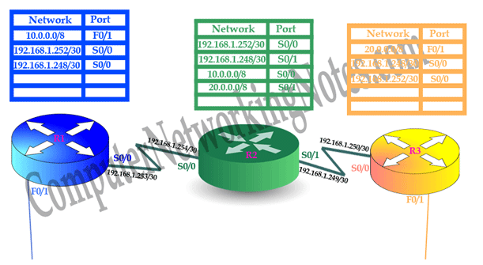

After 30 seconds (default time interval between two routing updates) all routers will again broadcast their routing tables with updated information.

**This time:-**

* R1 will broadcast for 10.0.0.0/8, 192.168.1.248/30 and 192.168.1.252/30.
* R2 will broadcast for 10.0.0.0/8, 20.0.0.0/8, 192.168.1.248/30 and 192.168.1.252/30.
* R3 will broadcast for 20.0.0.0/8, 192.168.1.248/30 and 192.168.1.252/30.
* R1 will learn about 20.0.0.0/8 network from R2’s broadcast.
* R2 has nothing to update from R1’s and R2’s broadcast.
* R3 will learn about 10.0.0.0/8 network from R2’s broadcast.

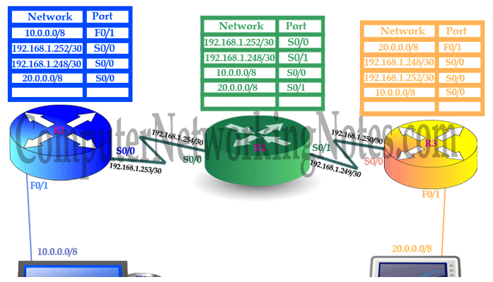

After 30 seconds router will broadcast again with new routing information. This time routers have nothing to update. This stage is known as **convergence**.

### Convergence

Convergence is a term that refers to the time taken by all routers in understanding the current topology of network.

## RIP Routing protocol metric

We may have two or more paths for the destination network. In this situation RIP uses a measurement called metric to determine the best path for destination network. RIP uses hops count as metric. Hops are the number of routers it takes to reach the destination network.

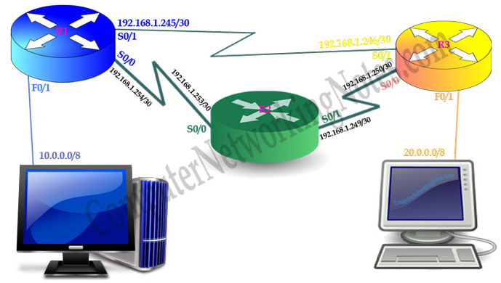

For example in above network R1 has two routes to reach the 20.0.0.0/8 network.

Route 1:- via R3 [on interface S0/1]. With hop count one.

Route 2:- via R2 – R3 [on interface S0/0]. With hop count two.

So which route will R1 take to reach the destination?

Route 1 has one hop count while route 2 has two hop counts. Route 1 has lower hop count so it will be placed in routing table.

## Routing Information Protocol Explained

This part of lab will explains RIP routing fundamentals difference between RIPv1 and RIPv2.

RIP is a distance vector routing protocol. It shares routing information through the local broadcast in every 30 seconds.

Routers keep only one route information for one destination in routing table. Routers use AD (Administrative Distance) value and metric to select the route.

## Key differences between RIPv1 and RIPv2

|  |  |
| --- | --- |
| **RIPv1** | **RIPv2** |
| It uses broadcast for routing update. | It use multicast for routing update. |
| It sends broadcast on 255.255.255.255 destination. | It sends multicast on 224.0.0.9 destination. |
| It does not support VLSM. | It supports VLSM. |
| It does not support any authentication. | It supports MD5 authentication |
| It only supports classful routing. | It supports both classful and classless routing. |
| It does not support discontiguous network. | It supports discontiguous network. |

## RIP Protocol Configuration

RIP is the simplest and one of the oldest Distance Vector routing protocol. It is very easy to setup and troubleshoot. For demonstration we will use packet tracer network simulator software. You can use real Cisco devices or any other network simulator software for following this guide.

Create a topology as illustrate in following figure:

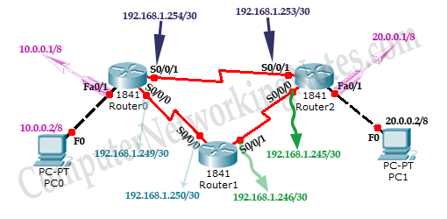

|  |  |  |  |
| --- | --- | --- | --- |
| **Device** | **Interface** | **IP Configuration** | **Connected with** |
| PC0 | Fast Ethernet | 10.0.0.2/8 | Router0’s Fa0/1 |
| Router0 | Fa0/1 | 10.0.0.1/8 | PC0’s Fast Ethernet |
| Router0 | S0/0/1 | 192.168.1.254/30 | Router2’s S0/0/1 |
| Router0 | S0/0/0 | 192.168.1.249/30 | Router1’s S0/0/0 |
| Router1 | S0/0/0 | 192.168.1.250/30 | Router0’s S0/0/0 |
| Router1 | S0/0/1 | 192.168.1.246/30 | Router2’s S0/0/0 |
| Router2 | S0/0/0 | 192.168.1.245/30 | Router1’s S0/0/1 |
| Router2 | S0/0/1 | 192.168.1.253/30 | Router0’s S0/0/1 |
| Router2 | Fa0/1 | 20.0.0.1/30 | PC1’s Fast Ethernet |
| PC1 | Fast Ethernet | 20.0.0.2/30 | Router2’s Fa0/1 |

Now routers have information about the networks that they have on their own interfaces. Routers will not exchange this information between them on their own. **We need to implement RIP routing protocol that will insist them to share this information.**

## Configure RIP routing protocol

Configuration of RIP protocol is much easier than you think. It requires only two steps to configure the RIP routing.

1. Enable RIP routing protocol from global configuration mode.
2. Tell RIP routing protocol which networks you want to advertise.

Let’s configure it in Router0

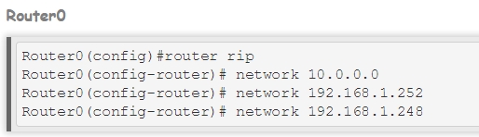

**router rip** command tell router to enable the RIP routing protocol.

**network** command allows us to specify the networks which we want to advertise. We only need to specify the networks which are directly connected with the router.

That’s all we need to configure the RIP. Follow same steps on remaining routers.

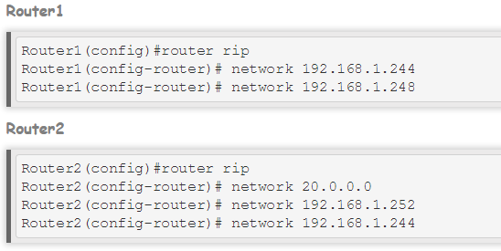

That’s it. Our network is ready to take the advantage of RIP routing. To verify the setup we will use ping command. ping command is used to test the connectivity between two devices.

Access the command prompt of **PC1** and use *ping* command to test the connectivity from **PC0**.

By default RIP will use the route that has low hops counts between source and destination. In our network route1 has low hops counts, so it will be selected. We can use ***tracert*** command to verify it.

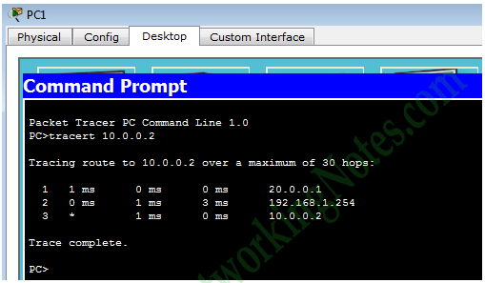

Now suppose route1 is down. We can simulate this situation by removing the cable attached between**Router0 [s0/0/1]** and **Router2 [s0/0/1]**.

Okay our primary route went down. What will be happen now?

So far we are running RIP routing protocol and have another route to destination, there is no need to worry. RIP will automatically reroute the traffic. Use ***tracert*** command again to see the magic of dynamic routing.

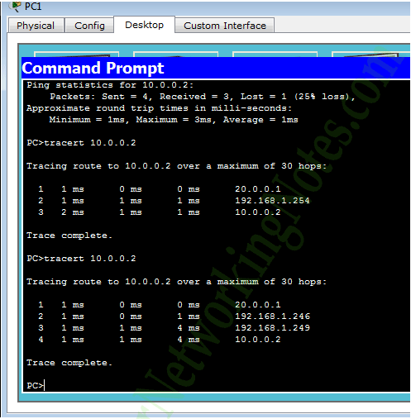

## RIP Routing protocol configuration commands summary

|  |  |
| --- | --- |
| **ommand** | **Description** |
| Router(config)#router rip | Enable RIP routing protocol |
| Router(config-router)#network a.b.c.d | Add a.b.c.d network in RIP routing advertisement |
| Router(config-router)#no network a.b.c.d | Remove a.b.c.d network from RIP routing advertisement |
| Router(config-router)#version 1 | Enable RIP routing protocol version one ( default) |
| Router(config-router)#version 2 | Enable RIP routing protocol version two |
| Router(config-router)#no auto-summary | By default RIPv2 automatically summarize networks in their default classful boundary. This command will turn it off. |
| Router(config-router)#passive-interface s0/0/0 | RIP will not broadcast routing update from this interface |
| Router(config-router)#no ip split-horizon | Disable split horizon ( Enable by default ) |
| Router(config-router)#ip split-horizon | Enable spilt horizon |
| Router(config-router)#timers basic 30 90 180 270 360 | Allow us to set RIP timer in seconds. 30 (routing update), 90 (invalid timer), 180 ( Hold timer), 270 (Flush timer), 360 (sleep timer) |
| Router(config)#no router rip | Disable RIP routing protocol |
| Router#debug ip rip | Used for troubleshooting. Allow us to view all RIP related activity in real time. |
| Router#show ip rip database | Display RIP database including routes |

## Exercise:

Implement all the concepts related to this lab using CISCO packet tracer and make a comprehensive lab report for submission.

**CCN Lab 13**

**Computer Communications & Networks**

## Enhanced Interior Gateway Routing Protocol (EIGRP)

# 1. Learning Objectives:

To become familiar with:

1. Enhanced Interior Gateway Routing Protocol (EIGRP).
2. Implementation of EIGRP using CISCO Packet Tracer.

# 2. Equipment Required:

A working computer having Cisco packet tracer installed.

# 3. Introduction:

EIGRP stands for Enhanced Interior Gateway Routing Protocol. It is a Cisco-proprietary routing protocol for TCP/IP. It is based on IGRP routing protocol. It has several enhancements to scale the enterprise size network.

## Features and characteristics of EIGRP

* It is a Cisco Proprietary routing protocol.
* It is based on IGRP Routing protocol.
* It is an enhanced version of IGRP (Interior Gateway Routing Protocol) protocol.
* In comparison of IGRP it provides faster convergence times, superior handling of routing loops and improved scalability.
* It was released in 1994.
* It is a hybrid routing protocol.
* It has characteristics of both distance vector and link state protocols.
* It uses DUAL (Diffusing Update Algorithm) algorithm to select the best path.
* It uses RTP (Reliable Transport Protocol) to communicate with neighbors.
* It uses multicast for routing updates.
* It supports IP [Both IPv4 and IPV6], Apple Talk and IPX routed protocols.
* It includes subnet mask information in routing updates.
* It supports route summarization and discontiguous networks.
* It supports VLSM/CIDR.
* It supports load balancing across the six routes for a single destination.
* It supports trigger updates.

EIGRP is ruling the world of routing protocols. The only negative about EIGRP was Cisco kept this protocol as proprietary protocol. In order to run this protocol, we had to buy all routers from Cisco. This thing was changed a little in 2013 when partial functionality of EIGRP was converted in open standard. Now we can also buy routers from other vendors along with Cisco, still running EIGRP on all routers.

Since EIGRP is hybrid protocol, it has advantages of both **link state and distance vector protocol**. It uses composite metric calculation formula to select the best route for destination. It sends partial or full update only when something is change in network. It maintains three tables for ultra-fast convergence.

1. Neighbor Table
2. Topology Table
3. Routing Table

## Metric

EIGRP uses metric to select the best route from all available routes for destination. Metric has five components.

1. Bandwidth
2. Load
3. Delay
4. Reliability
5. MTU (maximum transmission unit)

From these only bandwidth and delay are by default enabled.

## RTP

EIGRP uses RTP (Reliable Transport Protocol) to communicate with other EIGRP speaking routers. RTP uses **multicast and unicast** to exchange the data with neighbors. It uses class D address 224.0.0.10 for multicast. It keeps track of each multicast it sends out. EIGRP maintains a list of the neighbors who have replied. If it doesn’t receive a reply from any neighbor, RTP will resend the same data using unicast. It will make 16 unicast attempts before declaring neighbor is dead.

## DUAL (Diffusing Update Algorithm)

EIGRP uses DUAL (Diffusing Update Algorithm) to provide the fastest route convergence among all protocols. Route convergence includes:-

* Selecting best route from all available routes
* Supporting VLSMs
* Dynamically recovering from route failure
* Finding an alternative route if primary route goes down

## Administrative Distance (AD)

In a complex network, we may have multiple routing protocols running simultaneously. Different routing protocols use different metrics to calculate the best path for destination. In this situation router may receive different routes information for a single destination network. Routers use AD value to select the best path among these routes. Lower ad value has more trustworthiness.

|  |  |
| --- | --- |
| **AD value** | **Protocol / Source** |
| 0 | Directly connected interface |
| 0 or 1 | Static route |
| 90 | EIGRP (Interior) |
| 110 | OSPF |
| 120 | RIP |
| 170 | EIGRP (Exterior) |
| 255 | Unknown source |

## Autonomous System (AS)

EIGRP shares routing information only with neighbors. In order to become a neighbor AS number must be matched. AS create a logical boundary for route information. By default router will not propagate route information outside the AS. For example a router which belongs to AS number 10 will not share routing information with the router that belongs to AS number 20 or any other AS numbers except AS number 10. For easy administration a large network may have multiple ASes.

Not all routing protocols understand the concept of AS. Luckily EIGRP not only understand the concept of AS but also supports multiple ASes. We can easily configure multiple AS instance with EIGRP to divide a large network in smaller segments. By default EIGRP routers will not share routing information between different AS.

## Redistribution

**Redistribution** is used to exchange the route information between different ASes. When a route is learned through the redistribution, it has higher AD value than its original source. For example EIGRP has two AD values 90 for interior EIGRP and 170 for exterior EIGRP. Exterior EIGRP means EIGRP instance which has different AS number.

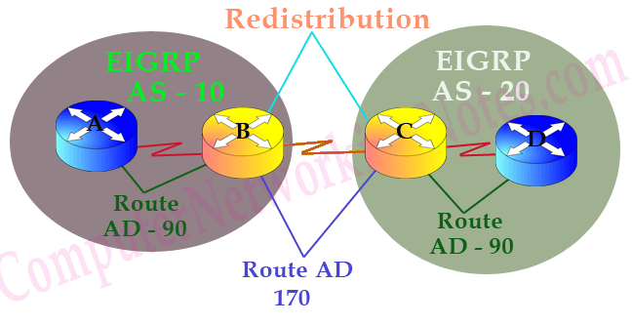

## EIGRP Neighborship Requirements And Conditions

In order to become an EIGRP neighbor, three essential configuration values must be matched;

1. Active hello packets,
2. AS number
3. and K-values.

### Active Hello packets

EIGRP uses hello packets to maintain the neighborship between routers. It uses them for neighbor discovery and recovery process. Hello packets are periodically sent from all active interfaces.

By default when we enable EIGRP routing, all interfaces (that meet network command criteria) become participate of it. EIGRP allows us to exclude any interface from it.

### AS Number

An AS is a group of networks running under a single administrative control. This could be our company or a branch of company. Just like Subnetting AS is also used to break a large network in smaller networks.

AS creates a boundary for routing protocol which allow us to control how far routing information should be propagated. Beside this we can also filter the routing information before sharing it with other AS systems. These features enhance security and scalability of overall network.

Basically AS concept was developed for large networks. Routing protocols which were developed for small networks such as RIP do not understand the concept of AS systems.

There are two types of routing protocols IGP and EGP.

* **IGP** (Interior Gateway Protocol) is a routing protocol that runs in a single AS such as RIP, IGRP, EIGRP, OSPF and IS-IS.
* **EGP** (Exterior Gateway Protocol) is a routing protocol that performs routing between different AS systems. Nowadays only BGP (Border Gateway Protocol) is an active EGP protocol.

To keep distinguish between different autonomous systems, AS numbers are used. An AS number start from 1 and goes up to 65535. Same as IP addresses, AS numbers are divided in two types; Private and public.

* **Public AS Numbers**: - We only need to use public numbers if we connect our AS with Internet backbone through the BGP routes. IANA (Numbers Authority) controls the public AS numbers.
* **Private AS Numbers**: - Private AS numbers are used to break our internal network into the smaller networks.

EIGRP routers that belong to different ASs don’t become neighbors therefore they don’t share any routing information.

So our second condition that needs to be fulfilled in order to become EIGRP neighbor is the same AS number. Two routers will become neighbors only when they see same AS number in each other's hello packets.

### K Values

EIGRP may use five metric components to select the best route for routing table. These are Bandwidth, Load, Delay, Reliability and MTU. By default EIGRP uses only two components; Bandwidth and delay. With K-Values we can control which components should be used in route metric calculation. For five metric components we have five K values.

|  |  |
| --- | --- |
| **K Values** | **Metric components** |
| K1 | Bandwidth |
| K2 | Load |
| K3 | Delay |
| K4 | Reliability |
| K5 | MTU |

Two routers must use same K Values in order to become the EIGPR neighbor. For example if one router is using three K- Values (K1, K2 and K3) while second router is using default K values (K1 and K3) then these two routers will never become neighbor.

In order to become EIGRP neighbor two routers must use same K values.

## EIGRP Neighbor Discovery process

Step 1:- First router R1 sends a hello packet from all active interfaces. This packet contains essential configuration values which are required to be a neighbor.

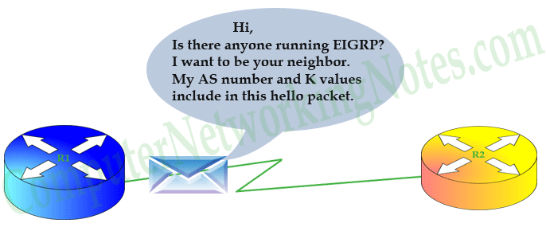

Step 2:- Receiving router R2 will compare these values with its own configuration values. If both necessary values match (AS number and K-values), it will reply with a routing update. This update includes all routes information from its routing table excluding one route. The route which it learned from the same interface that bring hello packet to it. This mechanism is known as **split horizon**. It states that if a router receives an update for route on any interface, it will not propagate same route information back to the sender router on same port. Split horizon is used to avoid routing loops.

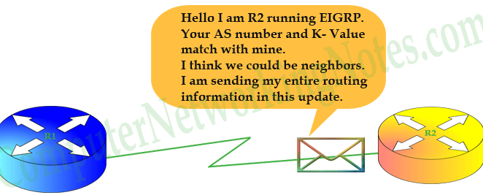

Step 3:- First router will receive R2’s routing update and sends an acknowledgement message back to R2.

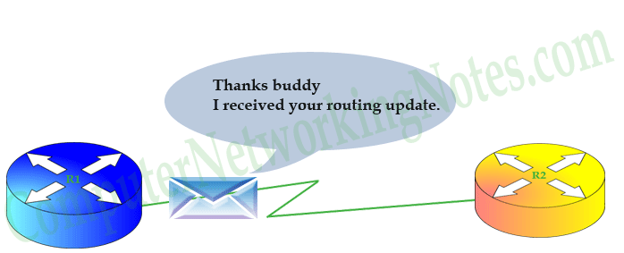

Step 4:- R1 will sync its EIGRP topology table with routing information that it received in routing update. It will also send a routing update containing all route information from its routing topology to R2.

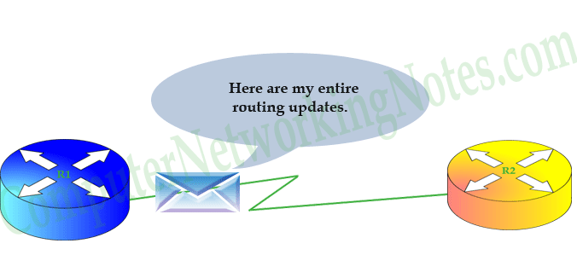

Step 5:- R2 will respond with an acknowledgement message. It will also sync its EIGRP topology table with routing information that it received in routing update.

## 

At this point, the two routers have becomes neighbor. Now they will maintain this neighborship with ongoing hello packets. If they see any change in network, they will update each other with partial updates.

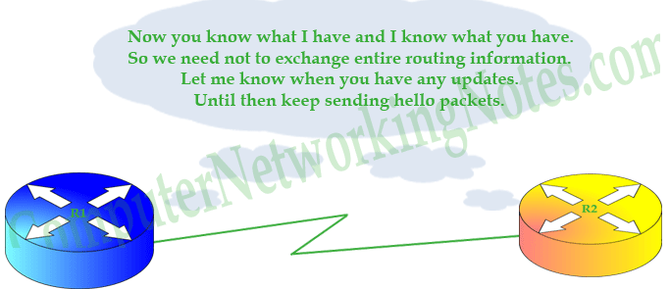

## EIGRP Configuration Step By Step Guide

EIGRP uses the concept of AS and Wildcard mask which makes its configuration part a little bit more complex.

Create a topology as illustrate in following figure:

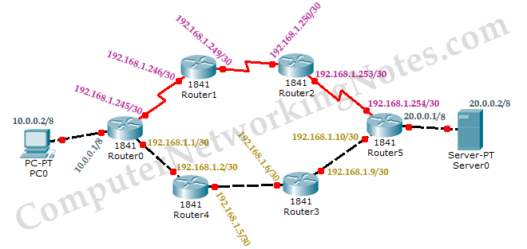

|  |  |  |  |
| --- | --- | --- | --- |
| **Device** | **Interface** | **IP Configuration** | **Connected with** |
| PC0 | Fa0/0 | 10.0.0.2/8 | Router0’s Fa0/0 |
| Router0 | Fa0/0 | 10.0.0.1/8 | PC0’s Fa0/0 |
| Router0 | Fa0/1 | 192.168.1.1/30 | Router4’s Fa0/1 |
| Router4 | Fa0/1 | 192.168.1.2/30 | Router0’s Fa0/1 |
| Router4 | Fa0/0 | 192.168.1.5/30 | Router3’s F0/0 |
| Router3 | Fa0/0 | 192.168.1.6/30 | Router4’s Fa0/0 |
| Router3 | Fa0/1 | 192.168.1.9/30 | Router5’s Fa0/1 |
| Router5 | Fa0/1 | 192.168.1.10/30 | Router3’s Fa0/1 |
| Router5 | Fa0/0 | 20.0.0.1/8 | Serve0’s Fa0/0 |
| Server | Fa0/0 | 20.0.0.2/8 | Router5’s Fa0/0 |
| Router5 | Se0/0/0 | 192.168.1.254/30 | Router2’s Se0/0/0 |
| Router2 | Se0/0/0 | 192.168.1.253/30 | Router5’s Se0/0/0 |
| Router2 | Se0/0/1 | 192.168.1.250/30 | Router1’s Se0/0/1 |
| Router1 | Se0/0/1 | 192.168.1.249/30 | Router2’s Se0/0/1 |
| Router1 | Se0/0/0 | 192.168.1.246/30 | Router0’s Se0/0/0 |
| Router0 | Se0/0/0 | 192.168.1.245/30 | Router1’s Se0/0/0 |

## Configure EIGRP routing protocol

Enabling EIGRP is a two steps process:

1. Enable EIGRP routing protocol from global configuration mode.
2. Tell EIGRP which interfaces we want to include.

For these steps following commands are used respectively.

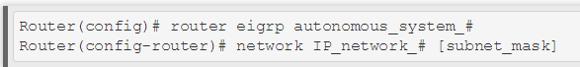

Router(config)# **router eigrp autonomous_system_#**

This command will enable EIGRP routing protocol in router. We can use any ASN (Autonomous System Number) from 1 to 65,535. In order to become EIGRP neighbors this number must be same on all participates.

Router(config-router)# **network IP_network_# [subnet_mask]**

This command allows us to specify the local interfaces which we want to include in EIGRP. Basically we define a range of addresses and router search for these addresses in local interfaces. If match found EIGRP will be enabled on that interface. Once enabled, EIGRP will starts advertising about the connected subnets with that interface.

We have two options while defining the range of addresses with network command

1. Without wildcard mask
2. With wildcard

### Without wildcard

Choosing this option allows us to configure the classful network. This option is very straightforward. All we need to do is, type the network ID with network command. For example network 172.168.0.0 command will enable EIGRP on all interfaces which belong to network 172.168.0.0.

What if I type network number instead of network ID?

Well in this situation EIGRP will automatically convert it back to network ID in which this network number is resides. **For example 172.168.1.1 will be converted back in 172.168.0.0.**

This creates another query. Why it will be converted in 172.168.0.0 instead of 172.168.1.0?

Answer of this question is hidden in classful configuration. In classful configuration EIGRP will match network addresses with in default boundary. Consider following figure:

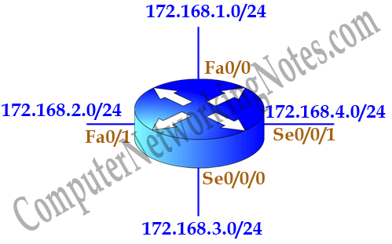

We have four networks 172.168.1.0/24, 172.168.2.0/24, 172.168.3.0/24 and 172.168.4.0/24 Subnetted from single class B network 172.168.0.0/16. **Classful configuration does not understand the concept of Subnetting**. In classful configuration all these networks belong to a single network. Classful configuration works only with in default boundary of mask. Default boundary of this address is 16 bits. So it will match only first 16 bits (172.168.x.y) of network address.

If we want excludes serial interfaces from EIGRP, we need to configure network command with more specific information.

### With wildcard

In this option we provide wildcard mask along with network ID. Wildcard mask allows us to match exact networks. With wildcard we are no longer limited with default boundaries. We can match Subnetted networks as well as default networks.

For example we were tasked to exclude serial interfaces in above configuration. We can use a wildcard mask of 0.0.0.255 to match the subnet mask of /24.

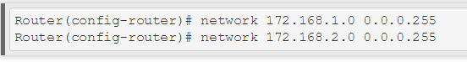

Above commands will ask router to match /24 bits of address instead of default /16 bits. Now router will look for 172.168.1.x and 172.168.2.x network. Our serial interfaces have 172.168.3.0/24 and 172.168.4.0/24 networks which do not fall in these search criteria.

Until you learn wildcard mask, use subnet mask in the place of wildcard mask. Following commands are also valid and do the same job by matching /24 bits of address.

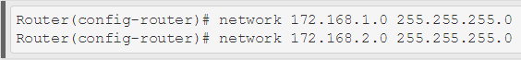

## EIGRP configuration

Now we know the essential commands for configuration. Let’s implement them in our network.

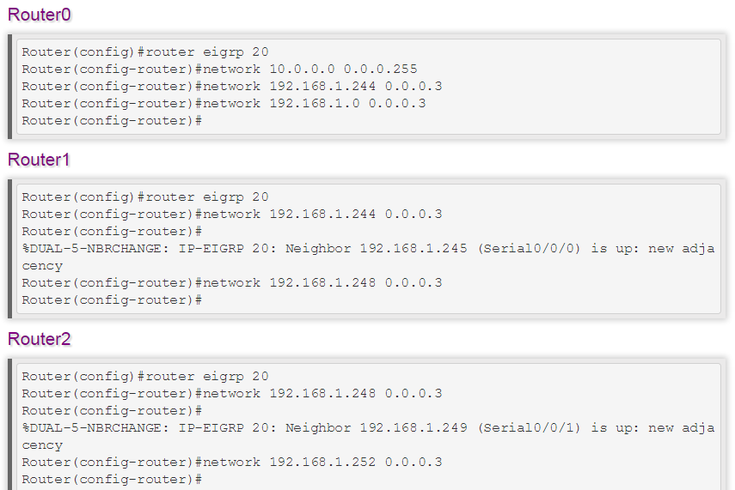

As I mentioned earlier, we can use both wildcard mask and subnet mask with network command. We have used wildcard mask for above routers. In remaining routers we will use subnet mask.

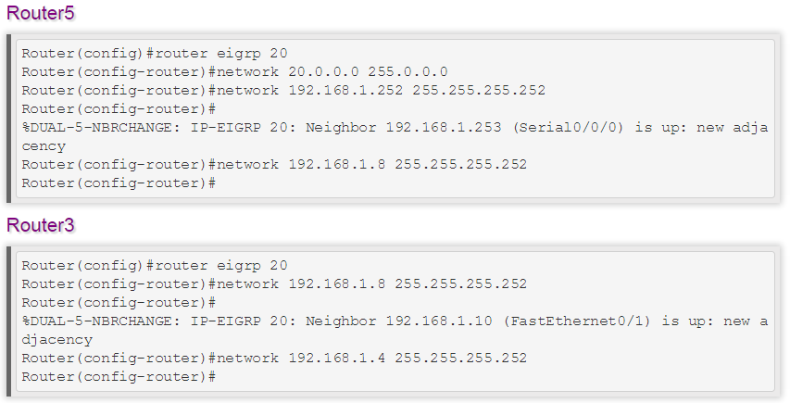

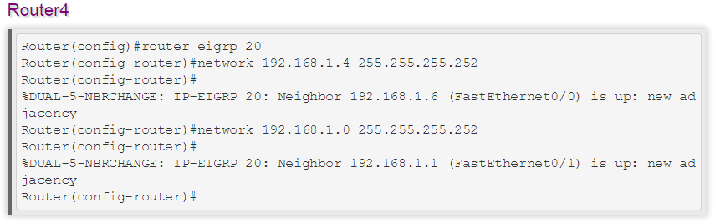

That’s it. Our network is ready to take the advantage of EIGRP routing. To verify the setup we will use **ping** command**. tracert** command is used to know the route which is used to get the destination.

Access the command prompt of PC1 and use ping command to test the connectivity from Server0. After that use tracert command to print the taken path.

## EIGRP configuration commands cheat sheet

|  |  |
| --- | --- |
| **Command** | **Description** |
| Router(config)#router eigrp 20 | Enable EIGRP with AS number 20. AS number must be same on all routers to become EIGRP neighbor. |
| Router(config-router)#network 10.10.0.0 | Enable EIGRP on interfaces which belongs to network 10.0.0.0/8. [Classful implementation]. |
| Router(config-router)#network 10.10.0.0 0.0.255.255 | Enable EIGRP on interfaces which belongs to network 10.10.0.0/16. [Classless implementation – Wildcard mask method]. |
| Router(config-router)#network 10.10.0.0 255.255.0.0 | Enable EIGRP on interfaces which belongs to network 10.10.0.0/16. [Classless implementation – Subnet mask method]. |
| Router(config-router)#no network 10.10.0.0 | Disable EIGRP on interfaces which belongs to network 10.0.0.0/8. |
| Router(config-router)#no network 10.10.0.0 0.0.255.255 | Disable EIGRP on interfaces which belongs to network 10.10.0.0/16. |
| Router(config-router)#no network 10.10.0.0 255.255.0.0 | Disable EIGRP on interfaces which belongs to network 10.10.0.0/16. |
| Router(config-router) #metric weights tos k1 k2 k3 k4 k5 | Enable/Disable K values used in metric calculation formula.  Default values are tos=0, k1=1, k2=0, k3=1, k4=0, k5=0  Tos(type of service), K1(bandwidth), K2(load), K3(delay), K4(reliability), K5(MTU).  By default only K1 and K3 are enabled. |
| Router(config-router)#auto-summary | Enable auto summarization feature of EIGRP. ( Default – disable ) |
| Router(config-router)#no auto-summary | Disable auto summarization feature of EIGRP. |
| Router(config)#no router eigrp 20 | Disable EIGRP routing process 20. |
| Router(config-if)#bandwidth 64 | Set bandwidth to 64Kbps. Used to influence the metric calculation. |
| Router#show ip eigrp neighbors | Display the neighbor table in brief. |
| Router#show ip eigrp neighbors detail | Display the neighbor table in detail. Used to verify whether a neighbor is configured as stub router or not. |
| Router#show ip eigrp interfaces | Display information about all EIGRP interfaces. |
| Router#show ip eigrp interfaces serial 0/0 | Display information about a particular EIGRP interface. |
| Router#show ip eigrp interfaces 20 | Display information about EIGRP interfaces running AS process 20. |
| Router#show ip eigrp topology | Displays the topology table. |
| Router#show ip eigrp traffic | Displays the number and type of packets sent and received. |
| Router#show ip route eigrp | Display EIGRP route from routing table. |
| Router#debug eigrp fsm | Displays the events or actions related to feasible successor metrics (FSM). |
| Router#debug eigrp packet | Displays the events or actions related to EIGRP packets. |
| Router#no debug eigrp fsm | Turn off debug message related to feasible successor metrics (FSM). |
| Router#no debug eigrp packet | Turn off debug message related to EIGRP packets. |

## Exercise:

Implement all the configuration and implementation commands of EIGRP using CISCO packet Tracer and make a lab report for your submission.

**CCN Lab 14**

**Computer Communications & Networks**

## Open Shortest Path First (OSPF)

# Learning Objectives:

To become familiar with:

1. OSPF
2. Implementation of OSPF using CISCO Packet Tracer

# Equipment Required:

A working computer having Cisco packet tracer installed.

# Introduction:

OSPF is a link state open standard based routing protocol. It was created in mid-1980. Since it is based on open standard, we can use it with any vendor’s router.

## Features and advantage of OSPF

* It supports both IPv4 and IPv6 routed protocols.
* It supports load balancing with equal cost routes for same destination.
* Since it is based on open standards, it will run on most routers.
* It provides a loop free topology using SPF algorithm.
* It is a classless protocol.
* It supports VLSM and route summarization.
* It supports unlimited hop counts.
* It scales enterprise size network easily with area concept.
* It supports trigger updates for fast convergence.
* Just like other routing protocols, OSPF also has its negatives.

## Disadvantage of OSPF

* It requires extra CPU process to run SPF algorithm.
* It requires more RAM to store adjacency topology.
* It is more complex to setup and hard to troubleshoot.

Basically OPSF was created to fulfill the requirement of enterprise size network. To scale a large size network it uses area concept. Area concept is similar to Subnetting. It allows us to separate the large internetwork into smaller networks known as **areas**.

Along with Area concept OSPF also supports Autonomous System (AS). Just like area, AS also divide a large network into smaller networks.

## OSPF Neighborship Condition And Requirement

OSPF routers share routing information only with neighbors. OSPF uses hello packets to discover neighbors in segments. A hello packet contains some essential configuration values that must be same on both routers who want to build an OSPF neighborship.

In order to become OSPF neighbor following values must be match on both routers.

1. Area ID
2. Authentication
3. Hello and Dead Intervals
4. Stub Flag
5. MTU Size

### Area ID

OSPF uses area concept to scale an enterprise size network. OSPF areas create a logical boundary for routing information. By default routers do not share routing information beyond the area. So in order to become neighbor, two routers must belong to same area. Here one confusing fact needs to clear. Area is associated with specific interface, not with entire router. This allows us to configure the router in multiple areas. For example a router that has two interfaces; **Serial interface and FastEthernet interface**, can run Serial interface in one area and FastEthernet in another area. It means link which connects two routers need be in same area including its both ends interface. Beside this interfaces should have same network ID and subnet mask.

Following figure illustrate a simple OSPF network. In this network R1 is eligible to form neighborship with R4 and R2 respectively on S0/0 and F0/0.

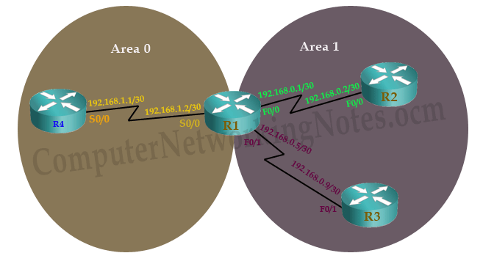

### Dead Intervals

As we already know once neighborship is built, hello packets are used to maintain the neighborship.

So a router must see hello packets from neighbor in particular time interval. This time interval is known as **dead interval**. Dead interval is the number of seconds that a router waits for hello packet from neighbor, before declaring it as dead.

Default dead interval is 40 seconds. If a router does not receive hello packet in 40 seconds from neighbor it will declare that as dead. When this happens, router will propagate this information to other OSPF neighboring router via LSA message.

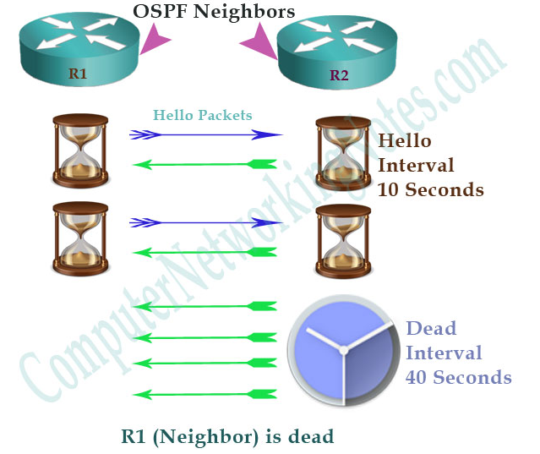

Hello and dead interval must be same between two neighbors. If any of these intervals are different, neighborship will not form.

### Stub Area Flag

This value indicates that whether sending router belong to stub area or not. Routers who want to build OPSF neighborship must have same **stub area flag**.

## MTU

Technically MTU (Maximum Transmission Unit) is not a part of compulsory matching conditions. Still we should match this value. If this value does not match routers may stuck in Exstart/Exchange exchange stage.

## OSPF Configuration Step By Step Guide

OSPF uses the concept of :

1. process ID,
2. area number
3. and Wildcard mask

Which makes its configuration a little bit more complex.

We will use packet tracer network simulator software. You can use **real Cisco devices** or any other network simulator software for following this guide.

Create a topology as illustrate in following figure:

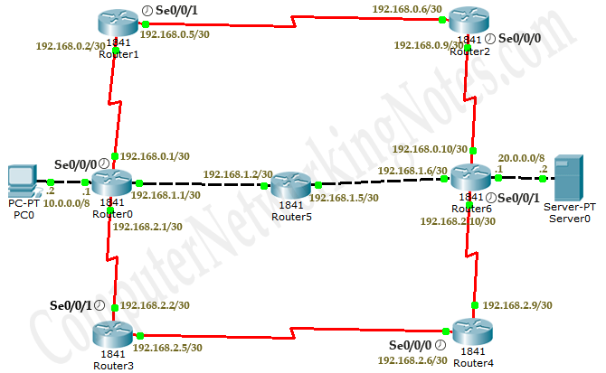

|  |  |  |  |
| --- | --- | --- | --- |
| **Device** | **Interface** | **IP Configuration** | **Connected with** |
| PC0 | Fa0/0 | 10.0.0.2/8 | Router0’s Fa0/0 |
| Router0 | Fa0/0 | 10.0.0.1/8 | PC0’s Fa0/0 |
| Router0 | Fa0/1 | 192.168.1.1/30 | Router5’s Fa0/1 |
| Router5 | Fa0/1 | 192.168.1.2/30 | Router0’s Fa0/1 |
| Router5 | Fa0/0 | 192.168.1.5/30 | Router6’s F0/0 |
| Router6 | Fa0/0 | 192.168.1.6/30 | Router5’s Fa0/0 |
| Router6 | Fa0/1 | 20.0.0.1/8 | Server0’s Fa0/0 |
| Server0 | Fa0/0 | 20.0.0.2/8 | Router6’s Fa0/1 |
| Router0 | Serial 0/0/0 (DCE) | 192.168.0.1/30 | Router1’s Se0/0/0 |
| Router1 | Serial 0/0/0 | 192.168.0.2/30 | Router0’s Se0/0/0 |
| Router1 | Serial 0/0/1 (DCE) | 192.168.0.5/30 | Router2’s Se0/0/1 |
| Router2 | Serial0/0/1 | 192.168.0.6/30 | Router1’s Se0/0/1 |
| Router2 | Serial 0/0/0 (DCE) | 192.168.0.9/30 | Router6’s Se0/0/0 |
| Router6 | Serial 0/0/0 | 192.168.0.10/30 | Router2’s Se0/0/0 |
| Router0 | Serial 0/0/1 | 192.168.2.1/30 | Router3’s Se0/0/1 |
| Router3 | Serial 0/0/1 (DCE) | 192.168.2.2/30 | Router0’s Se0/0/1 |
| Router3 | Serial 0/0/0 | 192.168.2.5/30 | Router4’s Se0/0/0 |
| Router4 | Serial 0/0/0 (DCE) | 192.68.2.6/30 | Router3’s Se0/0/0 |
| Router4 | Serial 0/0/1 | 192.168.2.9/30 | Router6’s Se0/0/1 |
| Router6 | Serial0/0/1 (DCE) | 192.168.2.10/30 | Router4’s Se0/0/1 |

## Configure OSPF routing protocol

Enabling OSPF is a two steps process:-

1. Enable OSPF routing protocol from global configuration mode.
2. Tell OSPF which interfaces we want to include.

For these steps following commands are used respectively.



Router(config)# **router ospf process ID**

This command will enable OSPF routing protocol in router. Process ID is a positive integer. We can use any number from 1 to 65,535. Process ID is locally significant. We can run multiple OSPF process on same router. Process ID is used to differentiate between them. Process ID need not to match on all routers.

Router(config-router)# **network IP_network_# [wildcard_mask] area [area number]**

Network command allows us to specify the interfaces which we want to include in OSPF process. This command accepts three arguments **network number**, **wildcard mask** and **area number**.

### Network number

Network number is network ID. We can use any particular host IP address or network IP address. For example we can use 192.168.1.1 (host IP address) or we can use 192.168.1.0 (Network IP address). While targeting a specific interface usually we use host IP address (configured on that interface).

While targeting multiple interfaces, we use network IP address. So any interface that belongs to specified network ID will be selected.

### Wildcard mask

Wildcard mask are used with network ID to filter the interfaces. Wildcard mask is different from subnet mask. Subnet mask is used to separate the network portion and host portion in IP address. While wildcard mask is used to match corresponding octet in network portion. Wildcard mask tells OSPF the part of network address that must be matched.

### Key points

0 (Decimal – octet format) Wildcard mask indicates that corresponding octet in network address must be matched exactly.

255 (Decimal – octet format) Wildcard mask indicates that we don’t care about corresponding octet in network address.

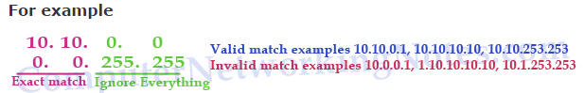

**0 (Binary – bit format)** Wildcard mask indicates that corresponding bit in network address must be matched exactly.

**255 (Binary – bit format**) Wildcard mask indicates that we don’t care about corresponding bit in network address.

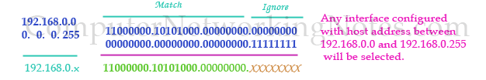

For example we want to exclude serial interfaces in above configuration. We can use a wildcard mask of 0.0.0.255 to match the subnet mask of /24.

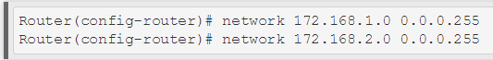

Above commands will ask router to match /24 bits of address instead of default /16 bits. Now router will look for 172.168.1.x and 172.168.2.x network. Our serial interfaces have 172.168.3.0/24 and 172.168.4.0/24 networks which do not fall in these search criteria.

Let’s take one more example, if we use following network command, which interfaces would be selected.

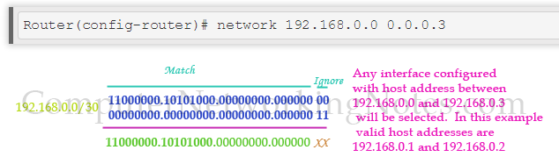

In this case valid host IP addresses are 192.168.0.1 and 192.168.0.2. So any interface that has these IP address would be selected. /30 network is usually used for serial link connection which need only two valid host IP addresses; one for each end.

Third argument which **network command** accept is area number. This parameter say router to put matched interface in specified area.

Now we know the essential commands for configuration. Let’s implement them in our network.

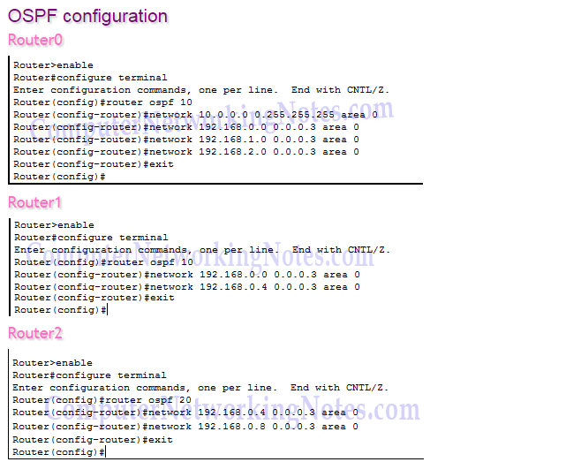

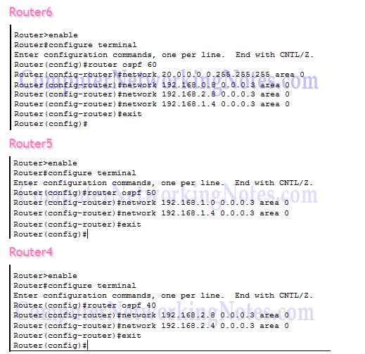

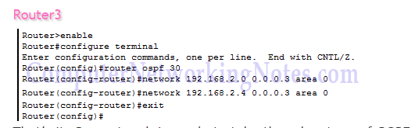

Our network is ready to take the advantage of OSPF routing. To verify the setup we will use **ping** command. **ping** command is used to test the connectivity between two devices. We have two routes between source and destination. **tracert** command is used to know the route which is used to get the destination.

Access the command prompt of PC1 and use ping command to test the connectivity from Server0. After that use **tracert** command to print the taken path.

## Summary

|  |  |
| --- | --- |
| **Command** | **Description** |
| Router(config)#router opsf 10 | Enable OSPF routing protocol under process ID 10. |
| Router(config-router)#network 10.10.0.0 0.0.255.255 area 0 | Enable OSPF with area 0 on matching interface. |
| Router(config)#interface loopback 0 | Create a Loopback interface and move in sub interface configuration mode |
| Router(config-if)#ip address 192.168.250.250 255.255.255.0 | Assign IP address to loopback interface. |
| Router(config-router)#router-id 1.1.1.1 | Set 1.1.1.1 as router ID |
| Router(config)#interface serial 0/0 | Inter in sub interface configuration mode |
| Router(config-if)#ip ospf priority 100 | Used to influence DR/BDR selection process. Valid range is 0 to 255. 0 makes router ineligible for DR/BDR while 255 makes router guaranteed DR/BDR. Higher priority value means higher chance of becoming DR/BDR. |
| Router(config-if)#bandwidth 256 | Used to influence route metric cost. Cost is the inverse of bandwidth. Higher bandwidth has lower cost. Bandwidth is defined in Kbps. 256 means 256 Kbps. |
| Router(config-if)#ip ospf hello-interval timer 15 | Set hello interval timer to 15 seconds. Hello timer must be match on both routers in order become neighbors. |
| Router(config-if)#ip ospf dead-interval 60 | Set dead interval timer to 60 seconds. Dead interval timer must be match on both routers in order to become neighbor |
| Router#show ip route | Display all routes from routing table |
| Router#show ip route ospf | Display all routers learned through OSPF from routing table |
| Router#show ip ospf | Display basic information about OSPF |
| Router#show ip ospf interface | Display information about all OSPF active interfaces |
| Router#show ip ospf interface serial 0/0/0 | Display OSPF information about serial 0/0/0 interface |
| Router#show ip ospf neighbor List all | OSPF neighbors with basic info |
| Router#show ip ospf neighbor detail | List OSPF neighbors with detail info |
| Router#show ip ospf database | Display data for OSPF database |
| Router#clear ip route * | Clear all routes from routing table. |
| Router#clear ip route 10.0.0.0/8 | Clear particular route from routing table |
| Router#clear ip ospf counters | Clear OSPF counters |
| Router#debug ip ospf events | Display all ospf events |
| Router#debug ip ospf packets | Display exchanged OSPF packets |
| Router#debug ip ospf adjacency | Display DR/BDR election process |

## Exercise:

Implement all the configuration and implementation commands of OSPF using CISCO packet Tracer and make a lab report for your submission.

**CCN Lab 15**

**Computer Communications & Networks**

## Virtual Local Area Network (VLAN)

# 1. Learning Objectives:

To become familiar with:

VLAN

Implementation of VLAN using CISCO Packet Tracer

# 2. Equipment Required:

A working computer having Cisco packet tracer installed.

# 3. Introduction:

## What is VLAN

VLAN is a logical grouping of networking devices. When we create VLAN, we actually break large broadcast domain in smaller broadcast domains. Consider VLAN as a subnet. Same as two different subnets cannot communicate with each other without router, different VLANs also requires router to communicate.

## Advantage of VLAN

VLAN provides following advantages:-

* Solve broadcast problem
* Reduce the size of broadcast domains
* Allow us to add additional layer of security
* Make device management easier
* Allow us to implement the logical grouping of devices by function instead of location

## VLAN Examples

To understand VLAN more clearly let's take an example.

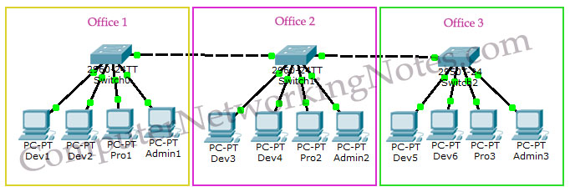

* Our company has three offices.
* All offices are connected with back links.
* Company has three departments **Development, Production and Administration**.
* Development department has six computers.
* Production department has three computers.
* Administration department also has three computers.
* Each office has two PCs from development department and one from both production and administration department.
* Administration and production department have sensitive information and need to be separate from development department.

With default configuration, all computers share same broadcast domain. Development department can access the administration or production department resources.

With VLAN we could create logical boundaries over the physical network. Assume that we created three VLANs for our network and assigned them to the related computers.

* VLAN Admin for Administration department
* VLAN Dev for Development department
* VLAN Pro for Production department

Physically we changed nothing but logically we grouped devices according to their function. These groups [VLANs] need router to communicate with each other. Logically our network look likes following diagram.

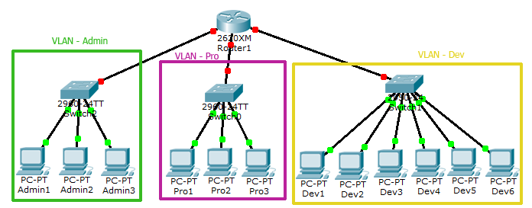

With the help of VLAN, we have separated our single network in three small networks. These networks do not share broadcast with each other improving network performance. VLAN also enhances the security. Now Development department cannot access the Administration and Production department directly. Different VLAN can communicate only via Router where we can configure wild range of security options.

### VLAN Membership

VLAN membership can be assigned to a device by one of two methods

1. Static
2. Dynamic

These methods decide how a switch will associate its ports with VLANs.

## Static

Assigning VLANs statically is the most common and secure method. It is pretty easy to set up and supervise. In this method we manually assign VLAN to switch port. VLANs configured in this way are usually known as port-based VLANs.

Static method is the most secure method also. As any switch port that we have assigned a VLAN will keep this association always unless we manually change it. It works really well in a networking environment where any user movement within the network needs to be controlled.

## Dynamic

In dynamic method, VLANs are assigned to port automatically depending on the connected device. In this method we have configure one switch from network as a server. Server contains device specific information like MAC address, IP address etc. This information is mapped with VLAN. Switch acting as server is known as VMPS (VLAN Membership Policy Server). Only high end switch can configured as VMPS. Low end switch works as client and retrieve VLAN information from VMPS.

Dynamic VLANs supports plug and play movability. For example if we move a PC from one port to another port, new switch port will automatically be configured to the VLAN which the user belongs. In static method we have to do this process manually.

## VLAN Connections

During the configuration of VLAN on port, we need to know what type of connection it has.

Switch supports two types of VLAN connection

1. Access link
2. Trunk link

### Access link

Access link connection is the connection where switch port is connected with a device that has a standardized Ethernet NIC (Network Interface Card). Standard NIC only understand IEEE 802.3 or Ethernet II frames. Access link connection can only be assigned with single VLAN. That means all devices connected to this port will be in same broadcast domain.

For example twenty users are connected to a hub, and we connect that hub with an access link port on switch, then all of these users belong to same VLAN. If we want to keep ten users in another VLAN, then we have to purchase another hub. We need to plug in those ten users in that hub and then connect it with another access link port on switch.

### Trunk link

Trunk link connection is the connection where switch port is connected with a device that is capable to understand multiple VLANs. Usually trunk link connection is used to connect two switches or switch to router. Trunking allows us to send or receive VLAN information across the network.

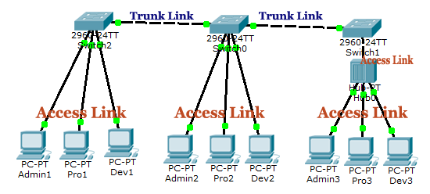

# VLAN Setup On Packet Tracer

## Scenario

You are a network administrator at FAST-CFD. Company has three offices. Offices are connected with each other via layer 2 links. For redundancy purpose each office has one more layer 2 link. Company has two departments EE and CS. In each office we have one PC from each department. Company has one router. You can use router's Ethernet port for inter VLAN communication.

To replicate given scenario create a topology in packet tracer, as shown in following image.

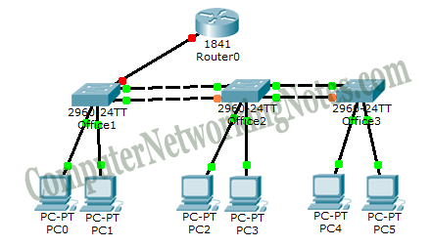

Configurations used in this topology are following:

**PCs Configuration**

|  |  |  |  |  |  |
| --- | --- | --- | --- | --- | --- |
| **Device** | **IP Address** | **Subnet Mask** | **Gateway** | **VLAN** | **Connected With** |
| PC0 | 10.0.0.2 | 255.0.0.0 | 10.0.0.1 | VLAN 10 | Office 1 Switch on F0/1 |
| PC1 | 20.0.0.2 | 255.0.0.0 | 20.0.0.1 | VLAN 20 | Office 1 Switch on F0/2 |
| PC2 | 10.0.0.3 | 255.0.0.0 | 10.0.0.1 | VLAN 10 | Office 2 Switch on F0/1 |
| PC3 | 20.0.0.3 | 255.0.0.0 | 20.0.0.1 | VLAN 20 | Office 2 Switch on F0/2 |
| PC4 | 10.0.0.4 | 255.0.0.0 | 10.0.0.1 | VLAN 10 | Office 3 Switch on F0/1 |
| PC5 | 20.0.0.4 | 255.0.0.0 | 20.0.0.1 | VLAN 20 | Office 3 Switch on F0/2 |

**Office 1 Switch Configuration**

|  |  |  |  |  |
| --- | --- | --- | --- | --- |
| **Port** | **Connected To** | **VLAN** | **Link** | **Status** |
| F0/1 | With PC0 | VLAN 10 | Access | OK |
| F0/2 | With PC1 | VLAN 20 | Access | OK |
| Gig1/1 | With Router | VLAN 10,20 | Trunk | OK |
| Gig 1/2 | With Switch2 | VLAN 10,20 | Trunk | OK |
| F0/24 | Witch Switch2 | VLAN 10,20 | Trunk | STP - Blocked |

**Office 2 Switch Configuration**

|  |  |  |  |  |
| --- | --- | --- | --- | --- |
| **Port** | **Connected To** | **VLAN** | **Link** | **Status** |
| F0/1 | With PC0 | VLAN 10 | Access | OK |
| F0/2 | With PC1 | VLAN 20 | Access | OK |
| Gig 1/2 | With Switch1 | VLAN 10,20 | Trunk | OK |
| Gig 1/1 | With Switch3 | VLAN 10,20 | Trunk | OK |
| F0/24 | Witch Switch1 | VLAN 10,20 | Trunk | STP - Blocked |
| F0/23 | Witch Switch3 | VLAN 10,20 | Trunk | STP - Blocked |

**Office 3 Switch Configuration**

|  |  |  |  |  |
| --- | --- | --- | --- | --- |
| **Port** | **Connected To** | **VLAN** | **Link** | **Status** |
| F0/1 | With PC0 | VLAN 10 | Access | OK |
| F0/2 | With PC1 | VLAN 20 | Access | OK |
| Gig 1/1 | With Switch2 | VLAN 10,20 | Trunk | OK |
| F0/24 | Witch Switch1 | VLAN 10,20 | Trunk | STP - Blocked |

**Router Configuration**

|  |  |  |  |  |
| --- | --- | --- | --- | --- |
| **Port** | **Connected To** | **VLAN** | **Link** | **Status** |
| Fa0/0 | with Office 1 Switch Gig 1/2 | VLAN 10, 20 | Trunk | Ok |

**VLAN Configuration**

|  |  |  |  |
| --- | --- | --- | --- |
| **VLAN Number** | **VLAN Name** | **Gateway IP** | **PCs** |
| 10 | Sales | 10.0.0.1 | PC0,PC2,PC4 |
| 20 | Management | 20.0.0.1 | PC1,PC3,PC5 |

## VLAN Configuration Commands Step By Step:

### How to create VLAN

In our network Office1 Switch is configured as VTP (VLAN Trunking Protocol) Server. Office2 and Office3 switches are configured as VTP clients. We only need to create VLANs in VTP Server. VTP Server will propagate this information to all VTP clients.

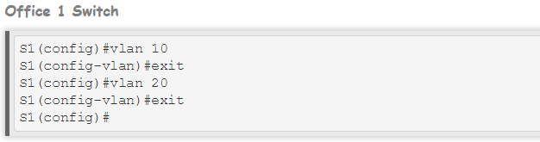

***vlan vlan number*** command is used to create the VLAN.

### How to assign VLAN Membership

VLAN can be assigned statically or dynamically.

***switchport access vlan [vlan number ]*** command is used to assign VLAN to the interface. Following commands will assign VLANs to the interfaces.

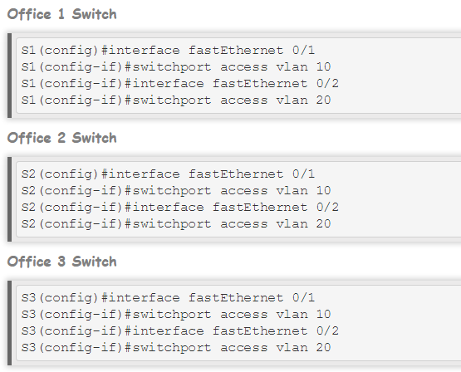

We have successfully assigned VLAN membership. It's time to test our configuration. To test this configuration, we will use ping command***. ping*** command is used to test connectivity between two devices. As per our configuration, **devices from same VLAN can communicate**. Devices from different VLANs must not be able to communicate with each other without router.

## Test VLAN configuration

## We have two VLAN configurations VLAN 10 and VLAN 20. Let's test VLAN 10 first. In VLAN 10 we have three PCs with IP addresses 10.0.0.2, 10.0.0.3 and 10.0.0.4. These PCs must be able to communicate with each other's. At this point PCs from VLAN 10 should not be allowed to access PCs from VLAN 20. VLAN 20 also has three PCs 20.0.0.2, 20.0.0.3 and 20.0.0.4.

Same as VLAN 10, PCs from VLAN 20 must be able to communicate with other PCs of same VLAN while they should not be able to access VLAN 10.

## Exercise:

Implement all the configuration and implementation commands of VLAN using CISCO packet Tracer and make a lab report for your submission.

**CCN Lab 16**

## **Computer Communications & Networks**

## VLAN Trunk Protocol (VTP) & Spanning Tree Protocol (STP)

# 1. Learning Objectives:

To become familiar with:

* VTP
* STP
* Implementation of VTP and STP using CISCO Packet Tracer

# 2. Equipment Required:

A working computer having Cisco packet tracer installed.

# 3. Introduction:

VLAN Trunk Protocol (VTP) is a Cisco proprietary protocol used to share VLAN configuration across the network. Cisco created this protocol to share and synchronize their VLAN information throughout the network. **Main goal of VTP is to manage all configured VLANs across the network**.

## Basic concepts of VTP Protocol

For understanding VTP, following topology running on packet tracer.

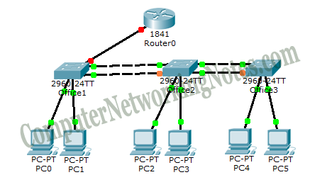

In our network we only have three switches. We can easily add or remove VLAN manually on all three switches. However this process could be more tedious and difficult if we have 50 switches. In a large network, we might make a mistake in VLAN configuration. We might forget to add VLAN on one of the switch, or we may assign wrong VLAN number. Vice versa we may forget to remove VLAN on one of the switch, while removing VLANs.

VTP is a life saver protocol in this situation. With VTP we can add or remove VLANs on one switch and this switch will propagate VLAN information to all other switches in network.

## VTP Messages

VTP share VLANs information via VTP messages. VTP messages can only be propagate through the trunk connections. So we need to set up trunk connection between switches. VTP messages are propagated as layer 2 multicast frames.

## VTP Domain

VTP domain is a group of switches that share same VLAN information. A switch can have a single domain. VTP messages include domain name. Switch only update VLAN information if it receive VTP message from same domain.

## VTP Mode

VTP can be configured in three different modes.

1. Server
2. Transparent
3. Client

## VTP Server Mode

VTP Server can add, modify, and delete VLANs. It will propagate a VTP message containing all the changes from all of its trunk ports. If server receives a VTP message, it will incorporate the change and forward the message from all remaining trunk ports.

## VTP Transparent Mode

VTP Transparent switch can also make change in VLANs but it will not propagate these changes to other switches. If transparent switch receives a VTP message, it will not incorporate the change and forward the message as it receives, from all remaining trunk ports.

## VTP Client Mode

VTP client switch cannot change the VLAN configurations itself. It can only update its VLAN configuration through the VTP messages that it receive from VTP server. When it receives a VTP message, it incorporates with the change and then forwards it from remaining trunk ports.

We will configure **Office 1 Switch** as VTP Server. Double click on **Office 1 Switch** and Click **CLI** menu item and press **Enter key** to start CLI session.

By default all switches work as VTP server so we only need few commands to configure it. In following commands we will

* Set hostname to **S1**
* Set domain name to *example*
* Set password to *vinita*. (Password is case sensitive)

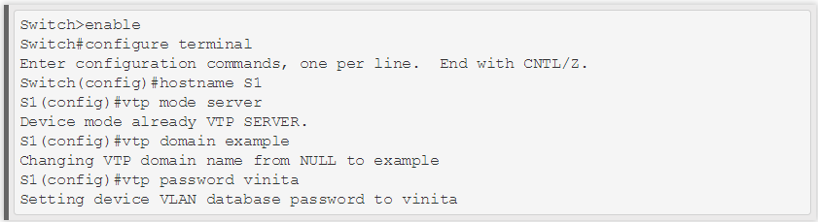

## Configure VTP Client

We will configure Office 2 Switch and Office 3 Switch as VTP client switch. Access **CLI** prompts of **Office 2 Switch** and execute following commands

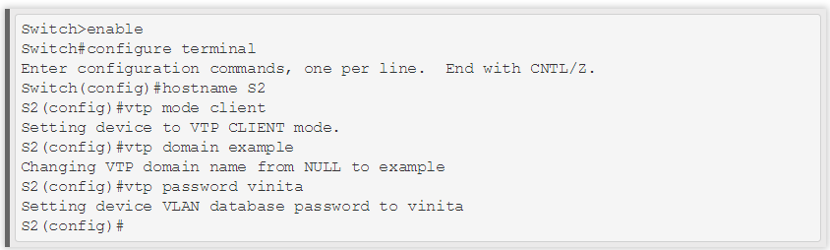

Now access **CLI** prompts of **Office 3 Switch** and enter following commands.

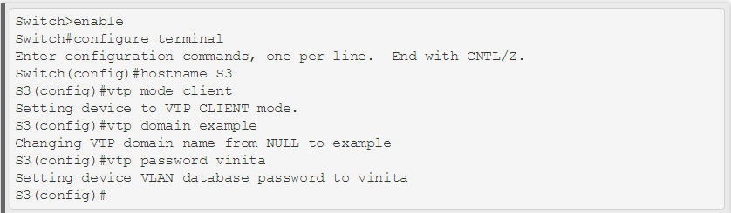

We have configured VTP server and VTP client.

# STP - Spanning Tree Protocol

For backup purpose we usually create redundant links. Redundant links are extremely useful in preventing entire network down situation that is triggered from single link failure. With all of its advantages, redundant link is a double edged sword. It creates network loops that flood down frames. STP removes loops as well as other evils of redundant link.

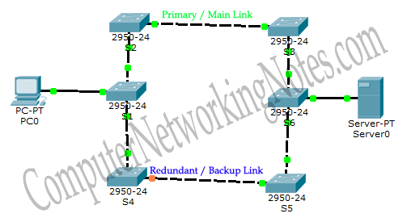

Above figure illustrates a simple layer 2 loop. In this network, LAN segment has two links to server.

* Primary / Main Link (S1, S2, S3, S6)
* Redundant / Backup Link (S1, S4, S5, S6)

Multiple layer 2 connections between LAN segment and server create following problems

1. Broadcast Storms
2. Duplicate Frame copies
3. Unstable MAC Table

### BPDU

BPDU (Bridge Protocol Data Unit) is a multicast frame that is used to share information about switch and its interface connections. Switches use BPDU to learn the network topology; other switches connections and any existing loops. BPDU frames are sent out as multicast in every two seconds.

### Root Bridge

All decisions in STP are made from the perspective of **Root Bridge**. Switch with the **lowest switch ID** is selected as Root Bridge. BPDU contains Switch ID. **Switch ID is made from priority of the switch and MAC address of switch itself**. Default priority is set to 32768. Switch with the lowest MAC address will be selected as the **root switch**, if you don’t change the default priority value. You can override root selection process by changing the priority value. If you want one switch to be Root Bridge, change its priority value to less than 32768.

Selection process of Root Bridge runs each time a network change occurs like as adding new switch in topology, removing existing switch or Root Bridge failure. If other switches in network do not receive BPDUs from Root Bridge within 20 seconds, they assume that Root Bridge has failed and will begin a new election process to choose a new Root Bridge.

### Non-Root Bridge

All other switches in network except Root Bridge are the Non-Root Bridges. Non-Root Bridge receives updates from Root Bridge and updates its STP database.

## Port Costs

STP assigns each port a cost, called port cost. Port cost is used to choose the best path when multiple links are available between two switches. Cost of port is determined by the bandwidth of connected media link. Switch always use lower port cost to forward the frames. Two set of port costs exist.

|  |  |  |
| --- | --- | --- |
| **Bandwidth** | **Old Cost Value** | **New Cost Value** |
| 10 Gbps | 1 | 2 |
| 1 Gbps | 1 | 4 |
| 100 Mbps | 10 | 19 |
| 10 Mbps | 100 | 100 |

Some old series switches like **Catalyst 1900** uses old cost value. Cisco already discontinued these old series switches. New series switches like 2960 uses new cost value. Lower cost value is always preferred over higher cost value while selecting link.

## Path Costs

Path cost is an accumulated value of port costs from Root Bridge to other switches in network. It is always calculated from Root Bridge. Default path cost at Root Bridge is 0. BPDU contains path cost information. When Root Bridge advertises BPDU out from its interface, it set path costs to 0. When connected switch receives this BPDU, it increments path cost by adding the port cost value of its incoming port.

For example if switch receive this BPDU on Gigabit interface then path cost would be 0 (Value it receive from Root Bridge) + 4 (port cost value, see above table) equal to 4. Now this switch will set path cost value to 4 in BPDU frame and forward it. Assume that next switch is connected with this switch and receives updated BPDU on **fast Ethernet port**. Path cost for new switch would be 23. Path costs value received in BPDU + Port cost ( 4+ 19 = 23).

## Root Port

Root port is a port that is directly connected with the Root Bridge, or has the shortest path to the Root Bridge. Shortest path is path that has lowest path cost value. Remember that switch can go through many other switches to get the root. So it’s not always the shortest path but it is the fastest path that will be used.

## Designated Port

Designated port is the port that is selected as having the lowest port cost. Designated port would be marked as forwarding port.

## Non-Designated Port

Non-designated port is the port that is selected as having the higher port cost than the designated port. Non-designated port would be marked as blocking port.

## Forwarding Port

### Forwarding port is used to forward the frames.

## Blocking Port

Blocking port remains disable to remove loops.

## STP port states

Ports on switch running STP go through the five different states. During STP convergence, switches will move their root and designated ports through the various states:

1. Blocking
2. Listening
3. Learning
4. Forwarding,

Whereas any other ports will remain in a blocked state.

### Blocking

In blocking state, switch only listen and process BPDUs on its ports. Any other frames except BPDUs are dropped. In this state, switch try to find out which port would be root port, which ports would be designated ports and which ports would remain in blocking state to remove loops. A port will remain in this state for twenty seconds. By default all ports are in blocking state, when we powered on the switch. Only root port and designated ports will move into next state. All remaining ports will remain in this state.

### Listening

After twenty seconds, root port and designated ports will move into listening state. In this state ports still listen and process only BPDUs. All other frames except BPDUs are dropped. In this state switch will double check the layer 2 topology to make sure that no loops occur on the network before processing data frames. Ports remain in this state for fifteen seconds.

### Learning

Root port and designated ports enter in learning state from listening state. In this state ports still listen and process BPDUs. However, in this state ports start processing user frames. Switch examines source address in the frames and updates its MAC Address Table. Switch will not forward user frames to destination ports in this state. Ports stay in this state for fifteen seconds.

### Forwarding

In forwarding state, ports will listen and process BPDUs. In this state ports will also process user frames, update MAC Address Table and forward user traffic through the ports.

## Disable

Disable ports are manually shut down or removed from STP by an administrator. All unplugged ports also remain in disable state. Disable ports do not participate in STP.

## Convergence

Convergence is a state where all ports on switch have transitioned to either forwarding or blocking modes. During the STP converging, all user data frames would be dropped. No user data frame will be forwarded until convergence is complete. Usually convergence takes place in fifty seconds (20 seconds of blocking state + 15 seconds of listing state + 15 seconds of learning state).

## STP Operations

First thing a STP enable network do, is the election of **Root Bridge**. Switches share BPDUs with each other to select the Root Bridge. Switch that has lowest priority will become root. Default priority is set to **32768**. If priority value is same then switch with **lowest MAC address** would be selected as root. In our network switch S3 has lowest MAC address. Since we did not change priority value, switch S3 would be chosen as Root Bridge.

* Every switch selects single port (that has shortest path cost) from all its ports and marked it as root port.
* If two switches have multiple connections, only single connection that has shortest path cost would be marked as designated port.
* Any port that is not either a root port or designated port would be **blocked**.

Below figure show, how STP changes a **physically looped topology** in **virtually looped free topology**.

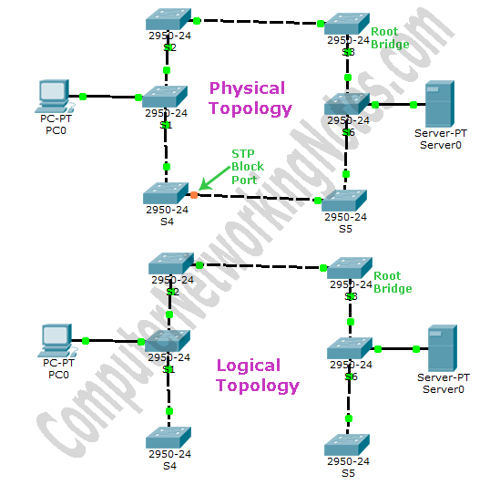

### show spanning-tree command

***show spanning-tree***  command provides useful information about STP operation. This information could be divided in three subsets. First set contains information about **Root Bridge**. Second set contains information about **switch itself**. Third set lists active interfaces status those are participating in STP operation.

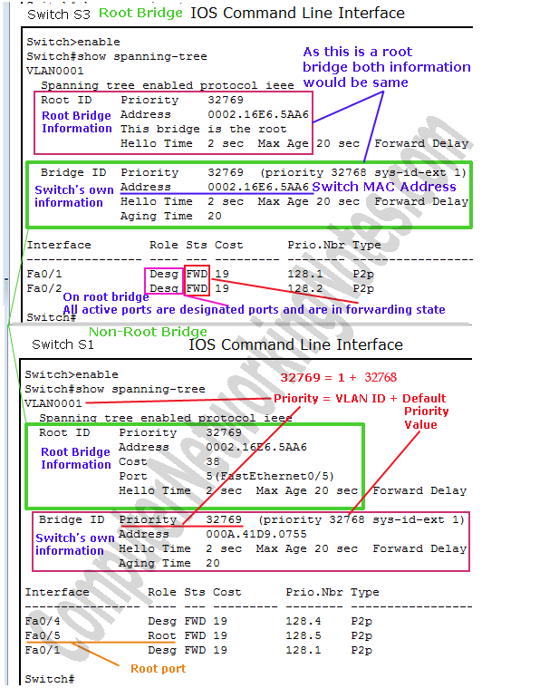

* On Root Bridge first and second subset information would be same.
* On non-Root Bridge first subset shows information about Root Bridge while second subset shows information about switch itself.

Priority value is a sum of default priority value and VLAN ID.